HIGH NOTE CASE STUDY – MIDTERM

Q1 - Summary statistics: Generate descriptive statistics for the key variables in the data set, similar to the table on the last page of the case. (Note that your table will look different because the data set you are analyzing is different from the one used to generate the table in the case.) Analyze the differences in the mean values of the variables, comparing the adopter and non-adapter subsamples. What tentative conclusions can you draw from these comparisons?

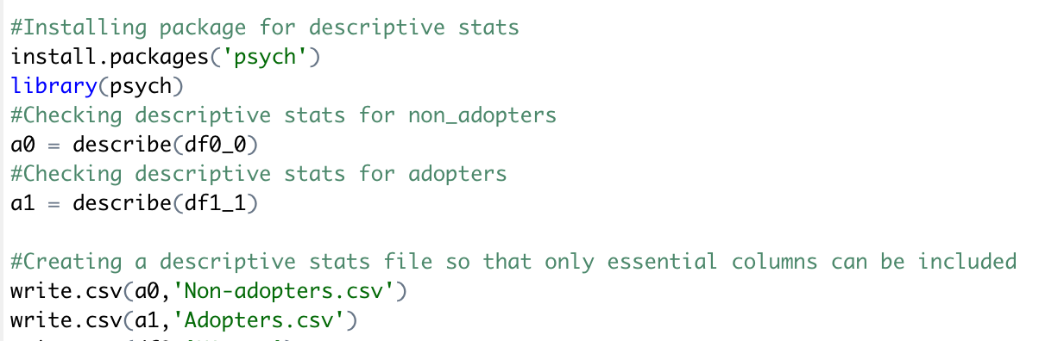

* Descriptive stats for Non-Adopters –

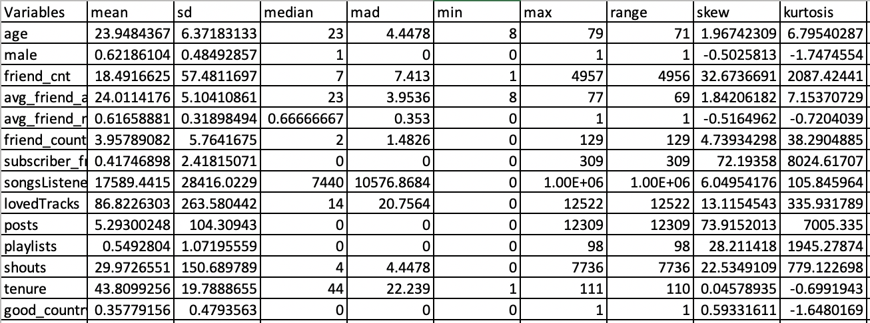

* Descriptive stats for Adopters –

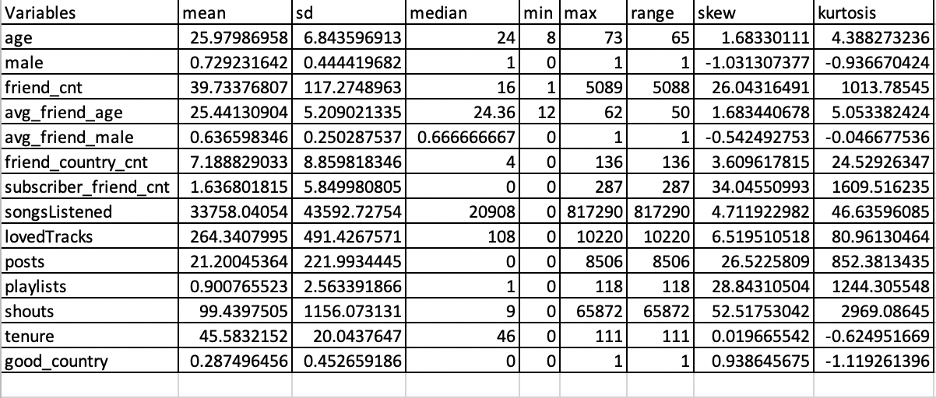

* After looking at the descriptive statistics of both adopters and non-adopters, it was observed that –
  1. Adopters are older people with an average age of approximately **26 years** than non-adopters with an average age of approximately **24 years**.
  2. Adopters have a greater number of friends which is approximately **40 friends** as compared to non-adopters with approximately **18 friends**. This may be thought of that there is a higher chance of adopter friends being converted to premium customers due to the social influence or **peer influence** of the adopter in that particular group of 40 friends.
  3. As far as friend’s are concerned, on an average there are **7 countries** which are represented by the adopter’s friends whereas on an average there are approximately **4 countries** which are represented by the non-adopter’s friends.

This shows that, **the reach** for High-Note is greater if a person is an adopter as he/she has friends with multiple nationalities or maybe residing in different countries.

* 1. There is a tendency that on an average, adopters tend to like more tracks than the non-adopters.
  2. An interesting insight is that even though adopters pay for the music service, on an average they **tend to stay longer** with High-Note musical than the non-adopters who use this service without spending a penny. This tells that the tracks that are present in High-Note’s database is according to its customers taste.
  3. If we look at the mean number of shouts, adopters have approximately **100 shouts on average** per post and non-adopters have a mere **30 shouts per post**. This shows that the users are quite active on High-Note’s music service and that the platform for the service seems to be attractive and users find it more intriguing

Q2 - Data Visualization: Generate a set of charts (e.g., scatter plots, box plots, etc.) to help visualize how adopters and non-adopters (of the premium subscription service) differ from each other in terms of (i) demographics, (ii) peer influence, and (iii) user engagement. What can you conclude from your charts?

* Demographics –

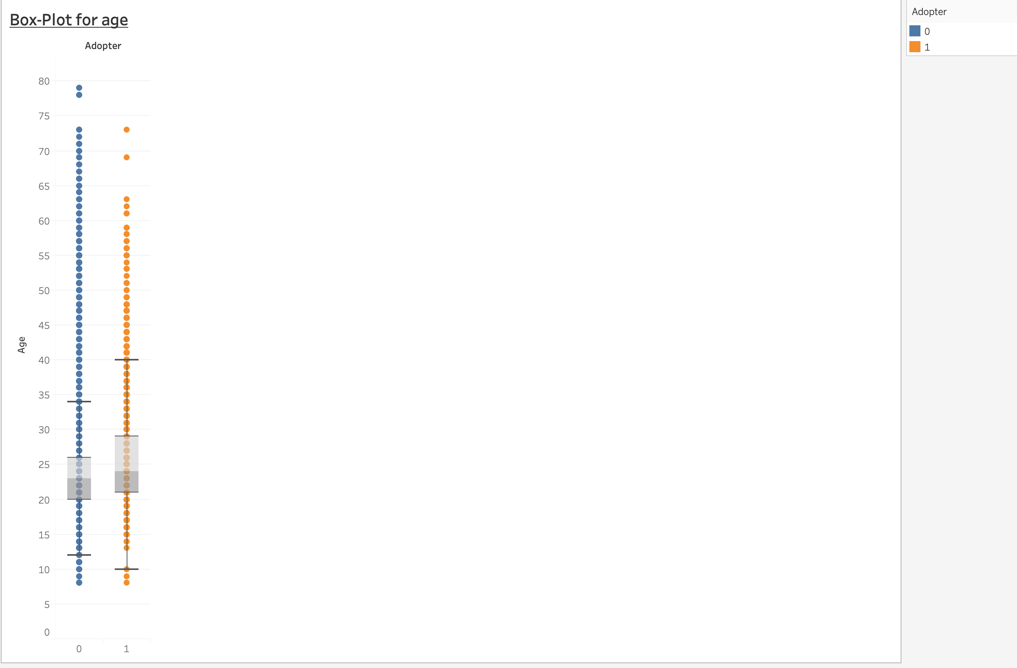

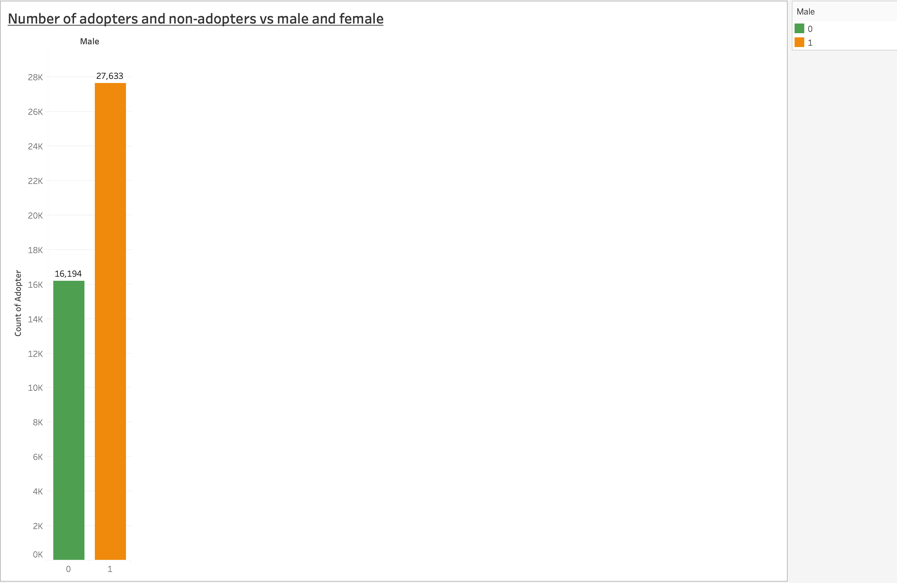

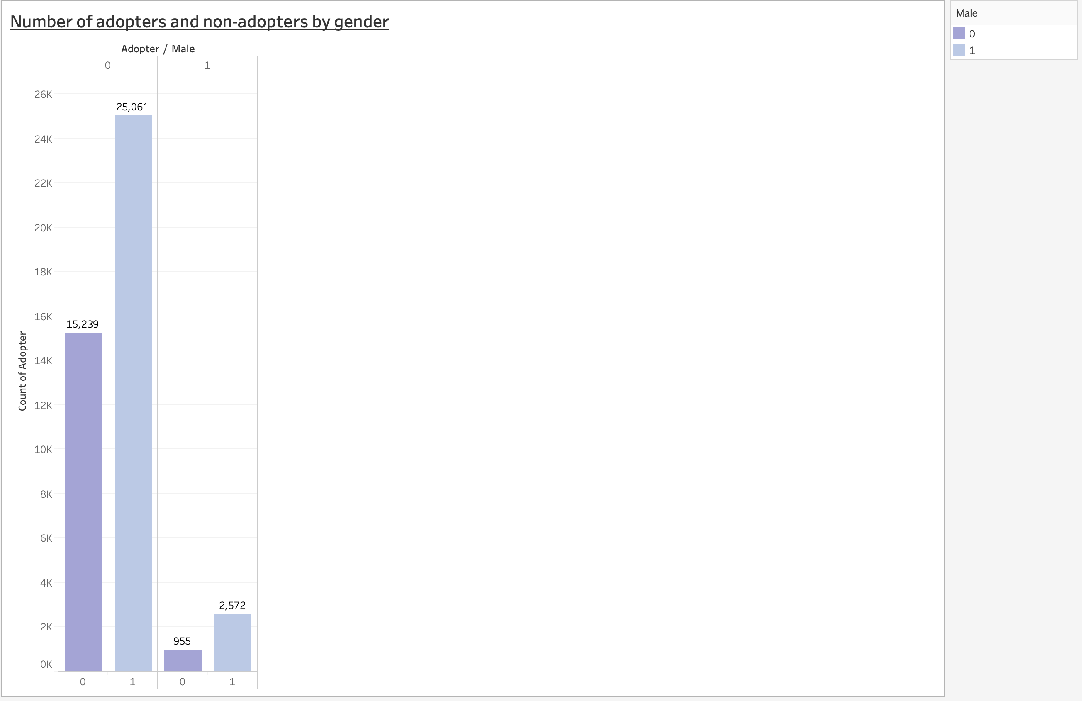

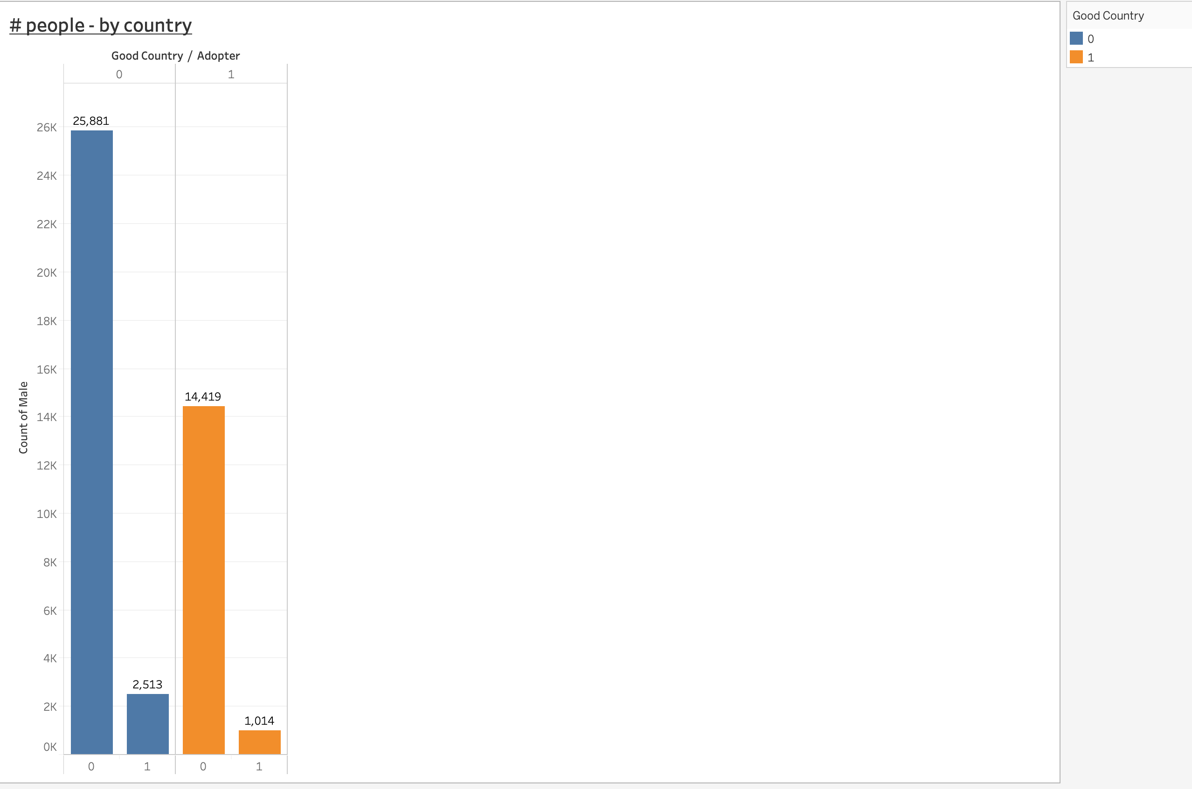

* After looking at the above plots for demographics, it can be concluded that: -
  1. The box plot for age shows that the spread of age data for both adopters and non-adopters is similar, and it has a lot of outliers. Additionally, the mean age of both adopters and non-adopters is almost same. This shows that the age bucket using the High-Note musical platform is of 20-30 years.
  2. The male and female bar plot by adopters and non-adopters depicts that High-Note has a majority of male users as compared to female users, irrespective of whether they are adopters or non-adopters.
  3. Looking at the number of adopters by gender, I found that there were 955 females who used the High-Note service whereas 2572 males used the same music service.
  4. After looking at number of people by country, it was found that most of the adopters belonged to any country except for US, UK or Germany. Thus, High-Note could possibly look at devising new strategies to promote their service in US, UK and Germany as these are developed countries which are economically very good and hence people will tend to buy these music services. Furthermore, most of the artist reside or have origins from these 3 countries and hence this may also help High-Note establish its footprints in these 3 countries.
* Peer Influence –

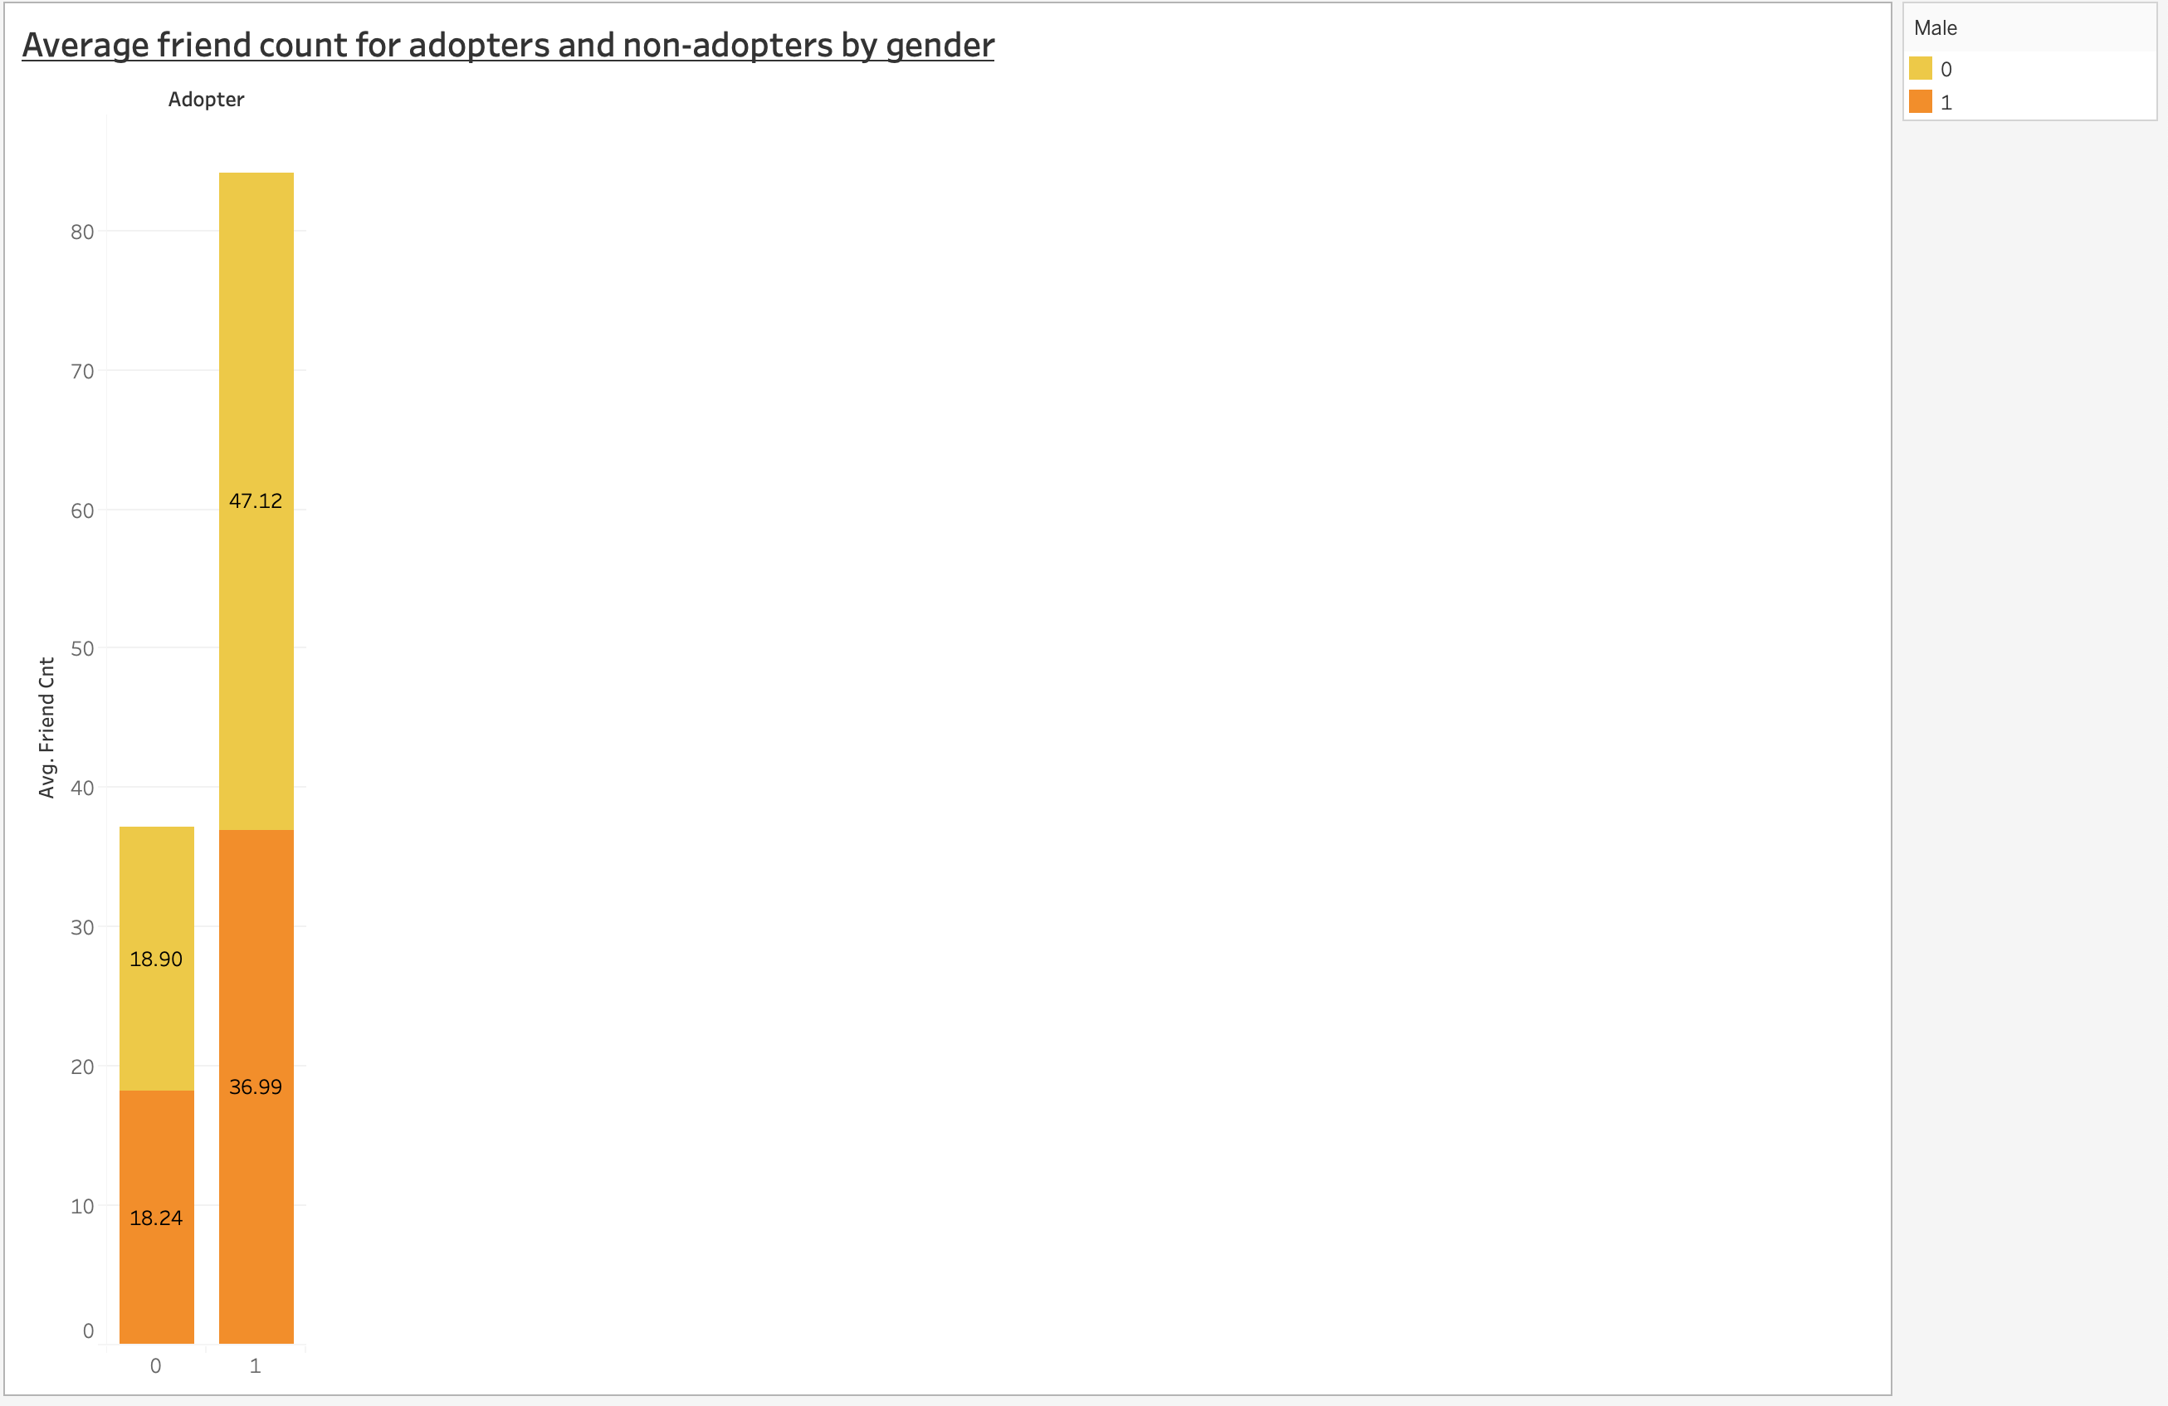

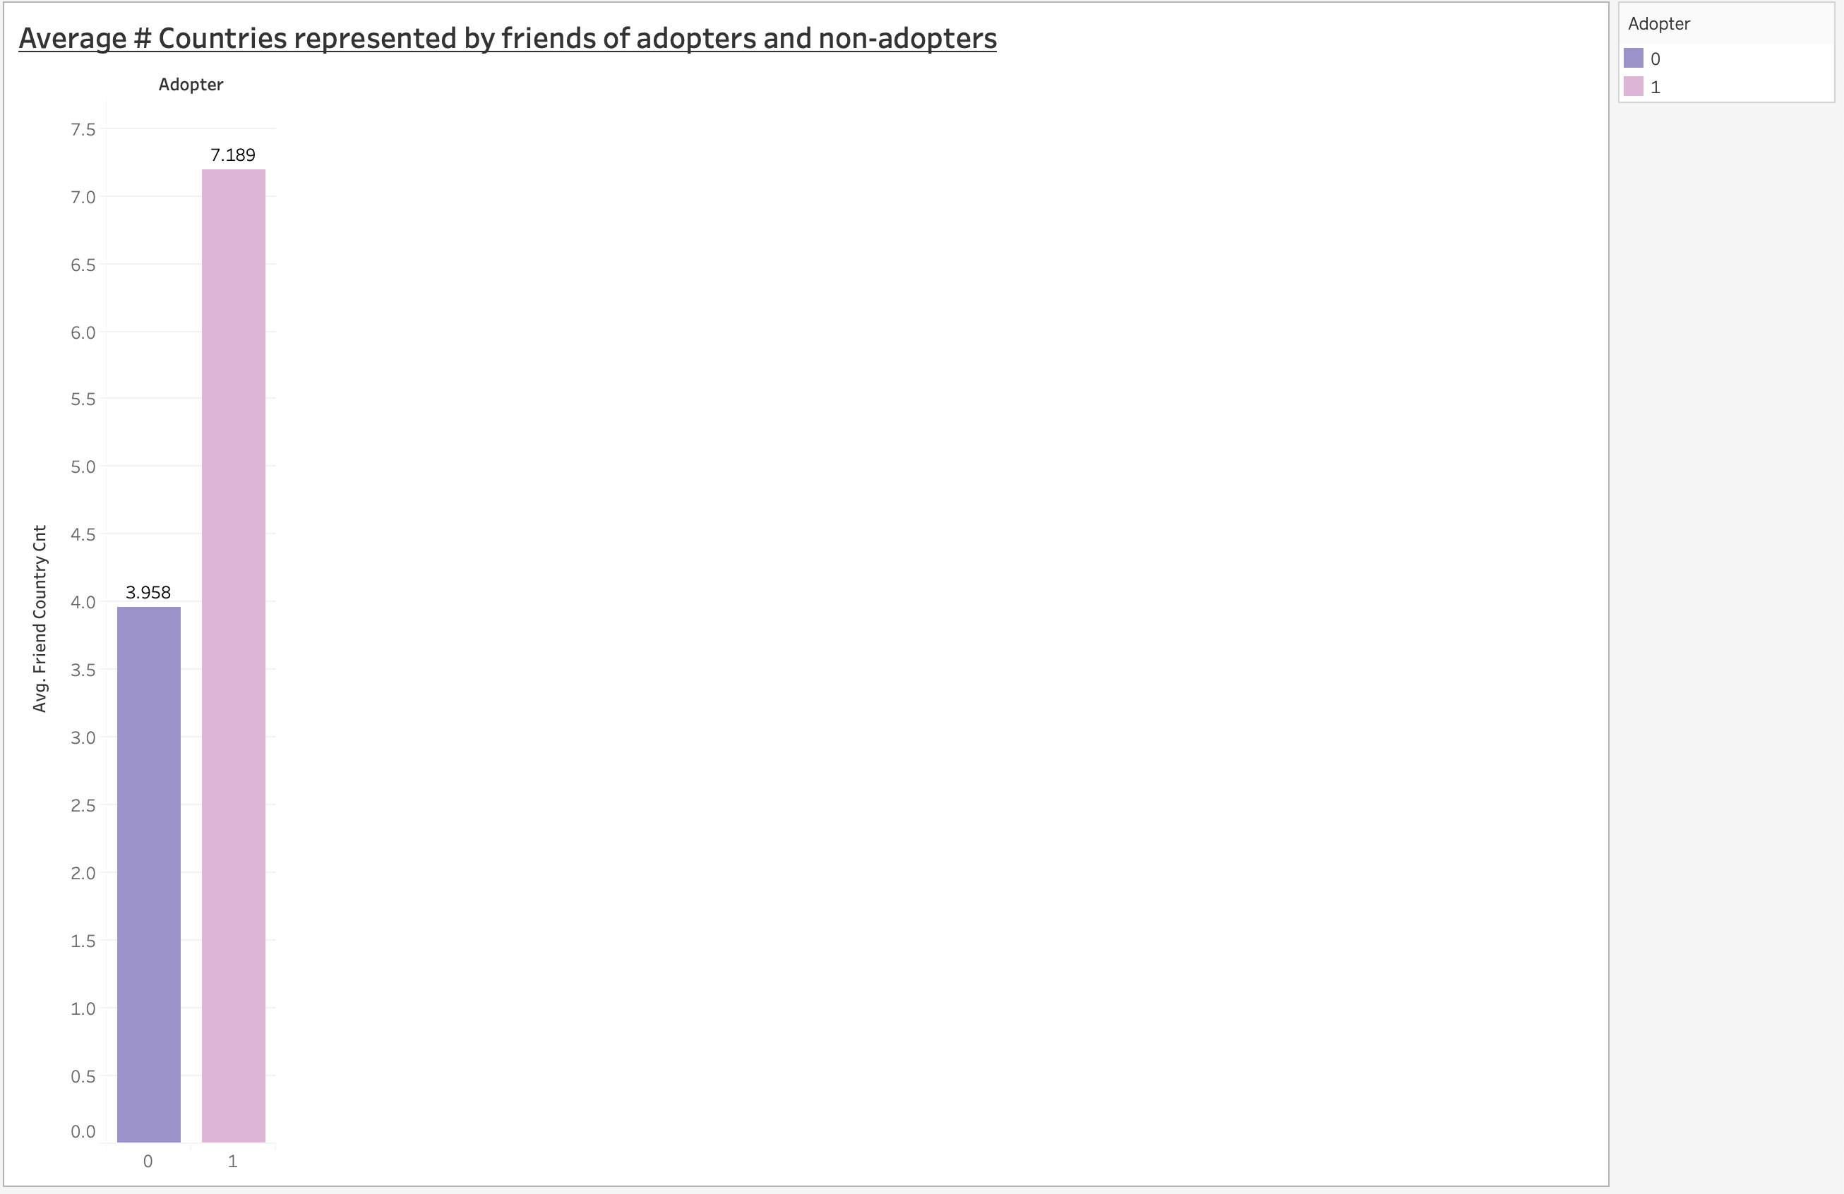

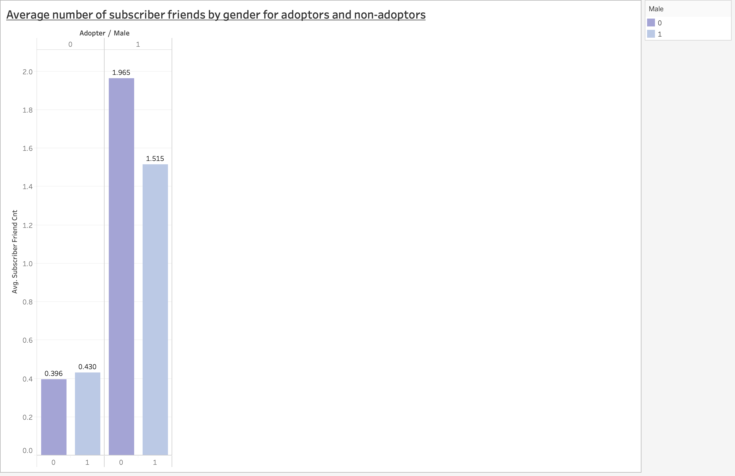

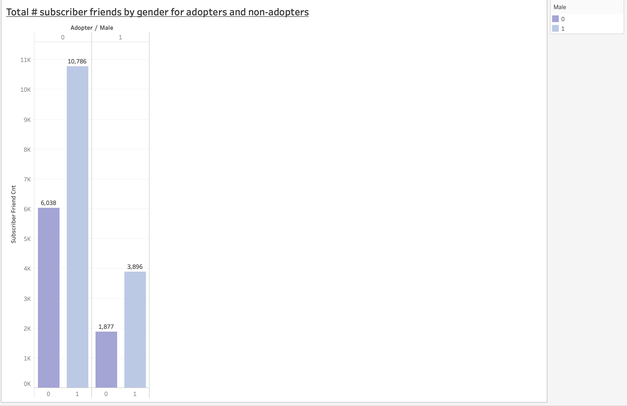

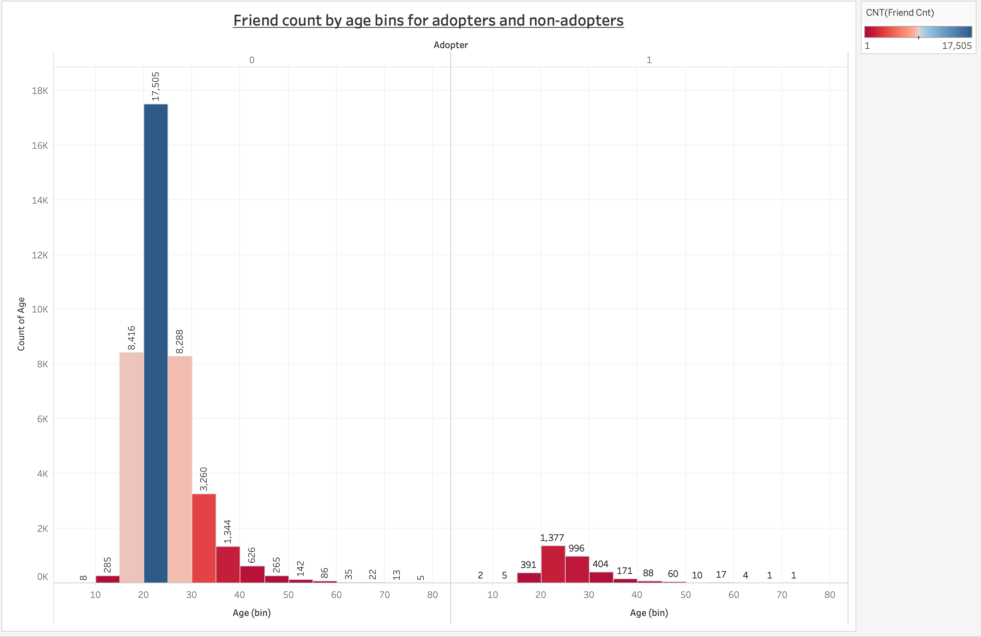

* After looking at the above plots –
  1. Looking at the plot for average # friends, it was observed that the average number of male and female friends for non-adopters were almost same, whereas adopters on average had a greater number of female friends than male friends.
  2. The plot for countries represented by friends of adopters and non-adopters depicts that adopters have a diverse community of friends with an average of 7 countries represented whereas non-adopters have an average of 3 countries represented by their friends. Thus, a global reach is possible due to this diverse group of friends for paid subscribers.
  3. If we look at the subscriber friends, then female adopters on an average have a higher number of friends as compared to the male adopters. Also, adopters have a higher number of friends as compared to non-adopters. Thus, these adopters can influence their friends and convert them from ‘free to fee’ customers.
  4. When we look at the histogram for age and the count of friends by age bins, we find that younger people from age group 20 years to 25 years have greater number of friends in both adopters and non-adopters. Thus, High-Note can include more of the pop or EDM music which the younger generation or people like so that the friends of this age bin from 20-25 can also be attracted to the paid service.
* User Engagement –

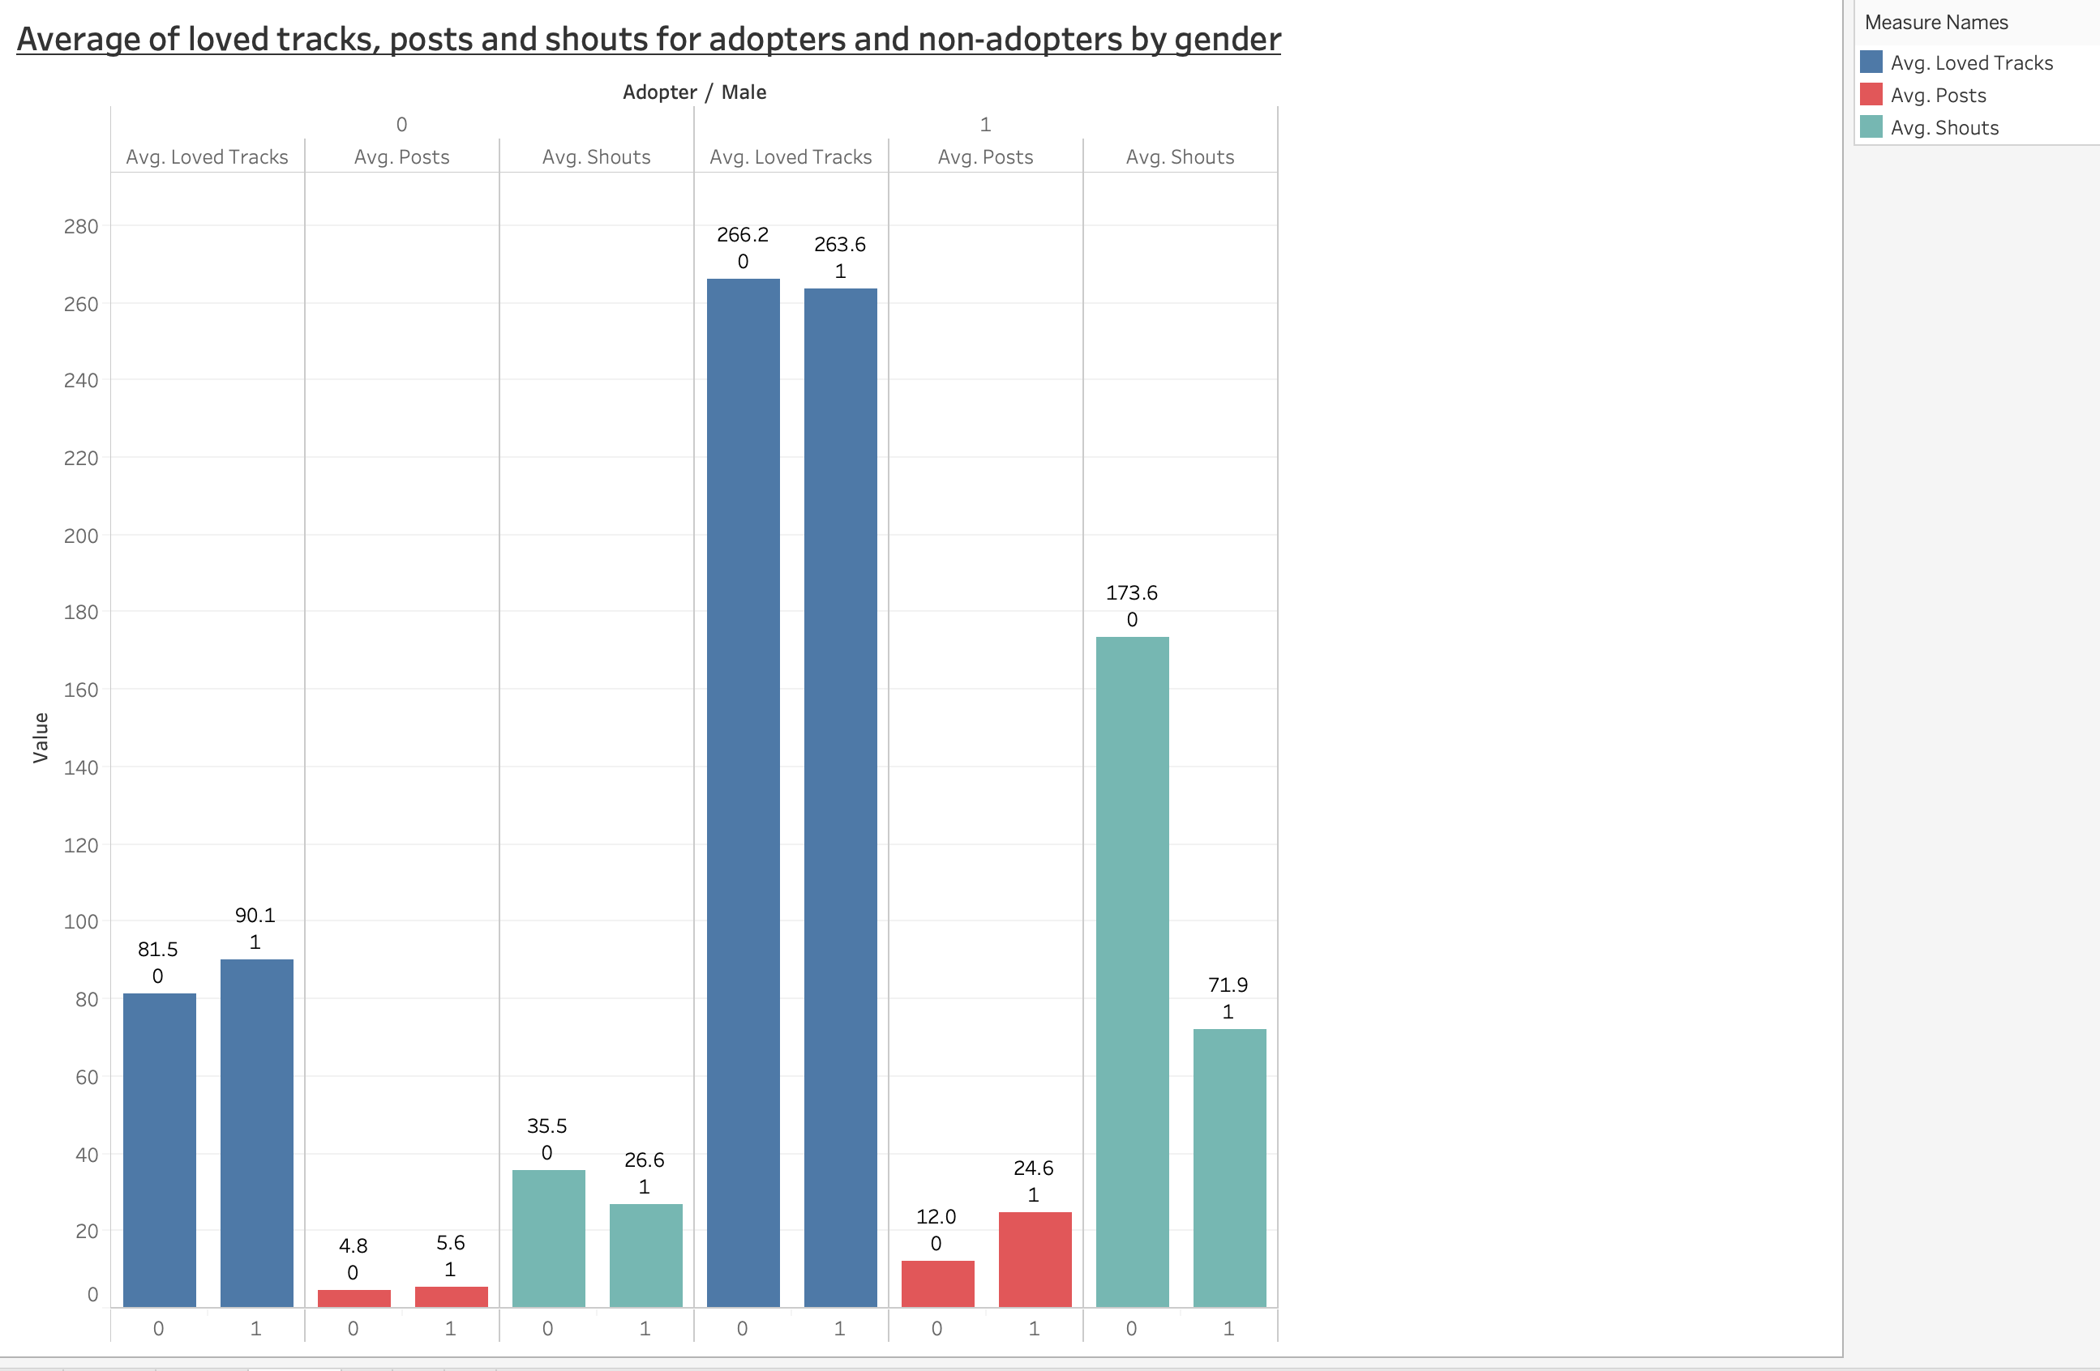

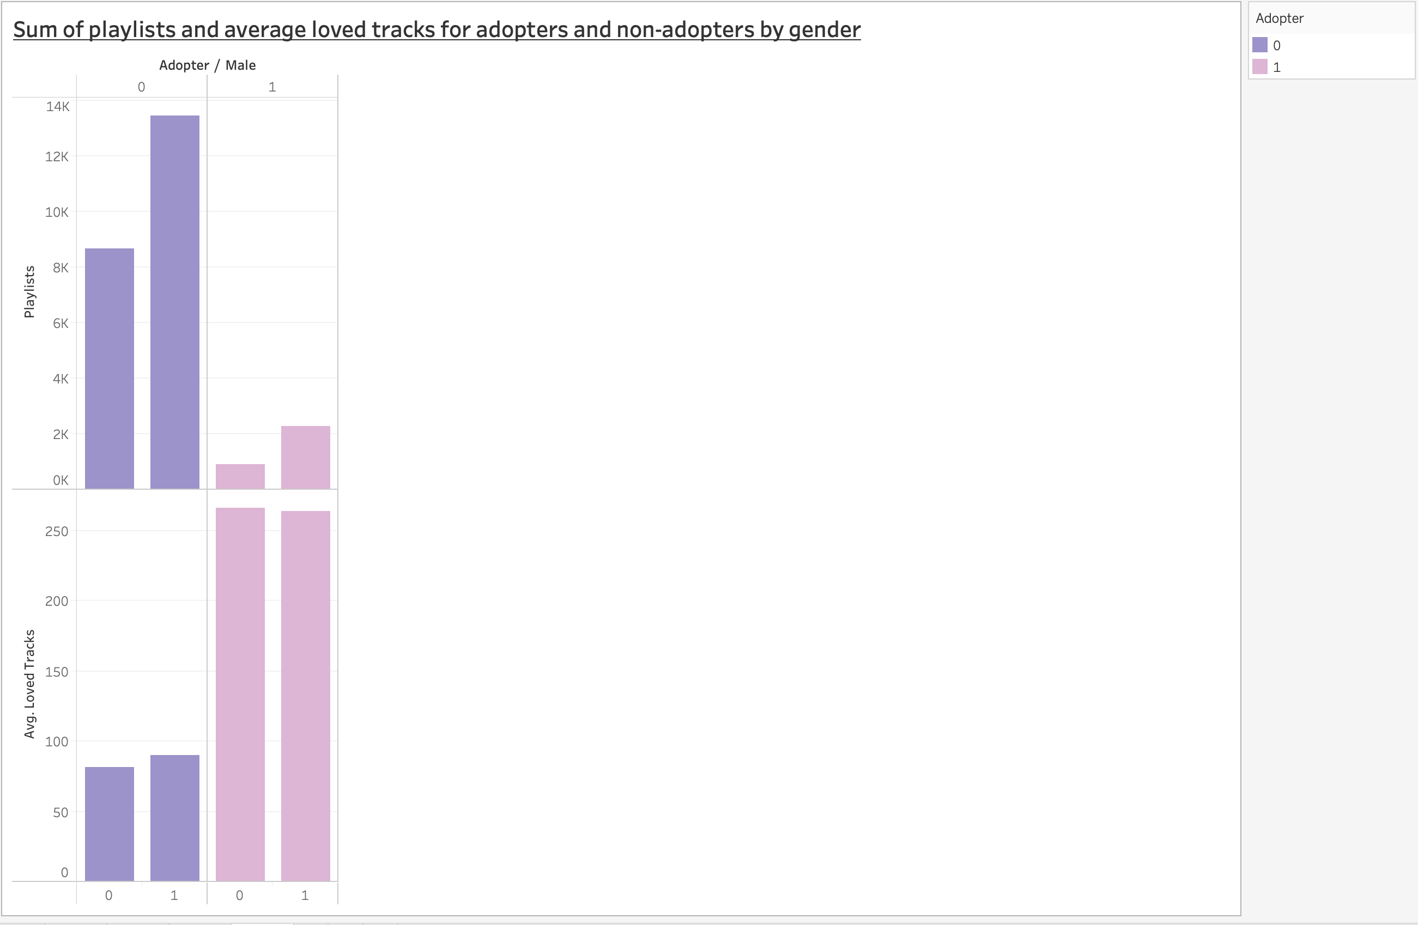

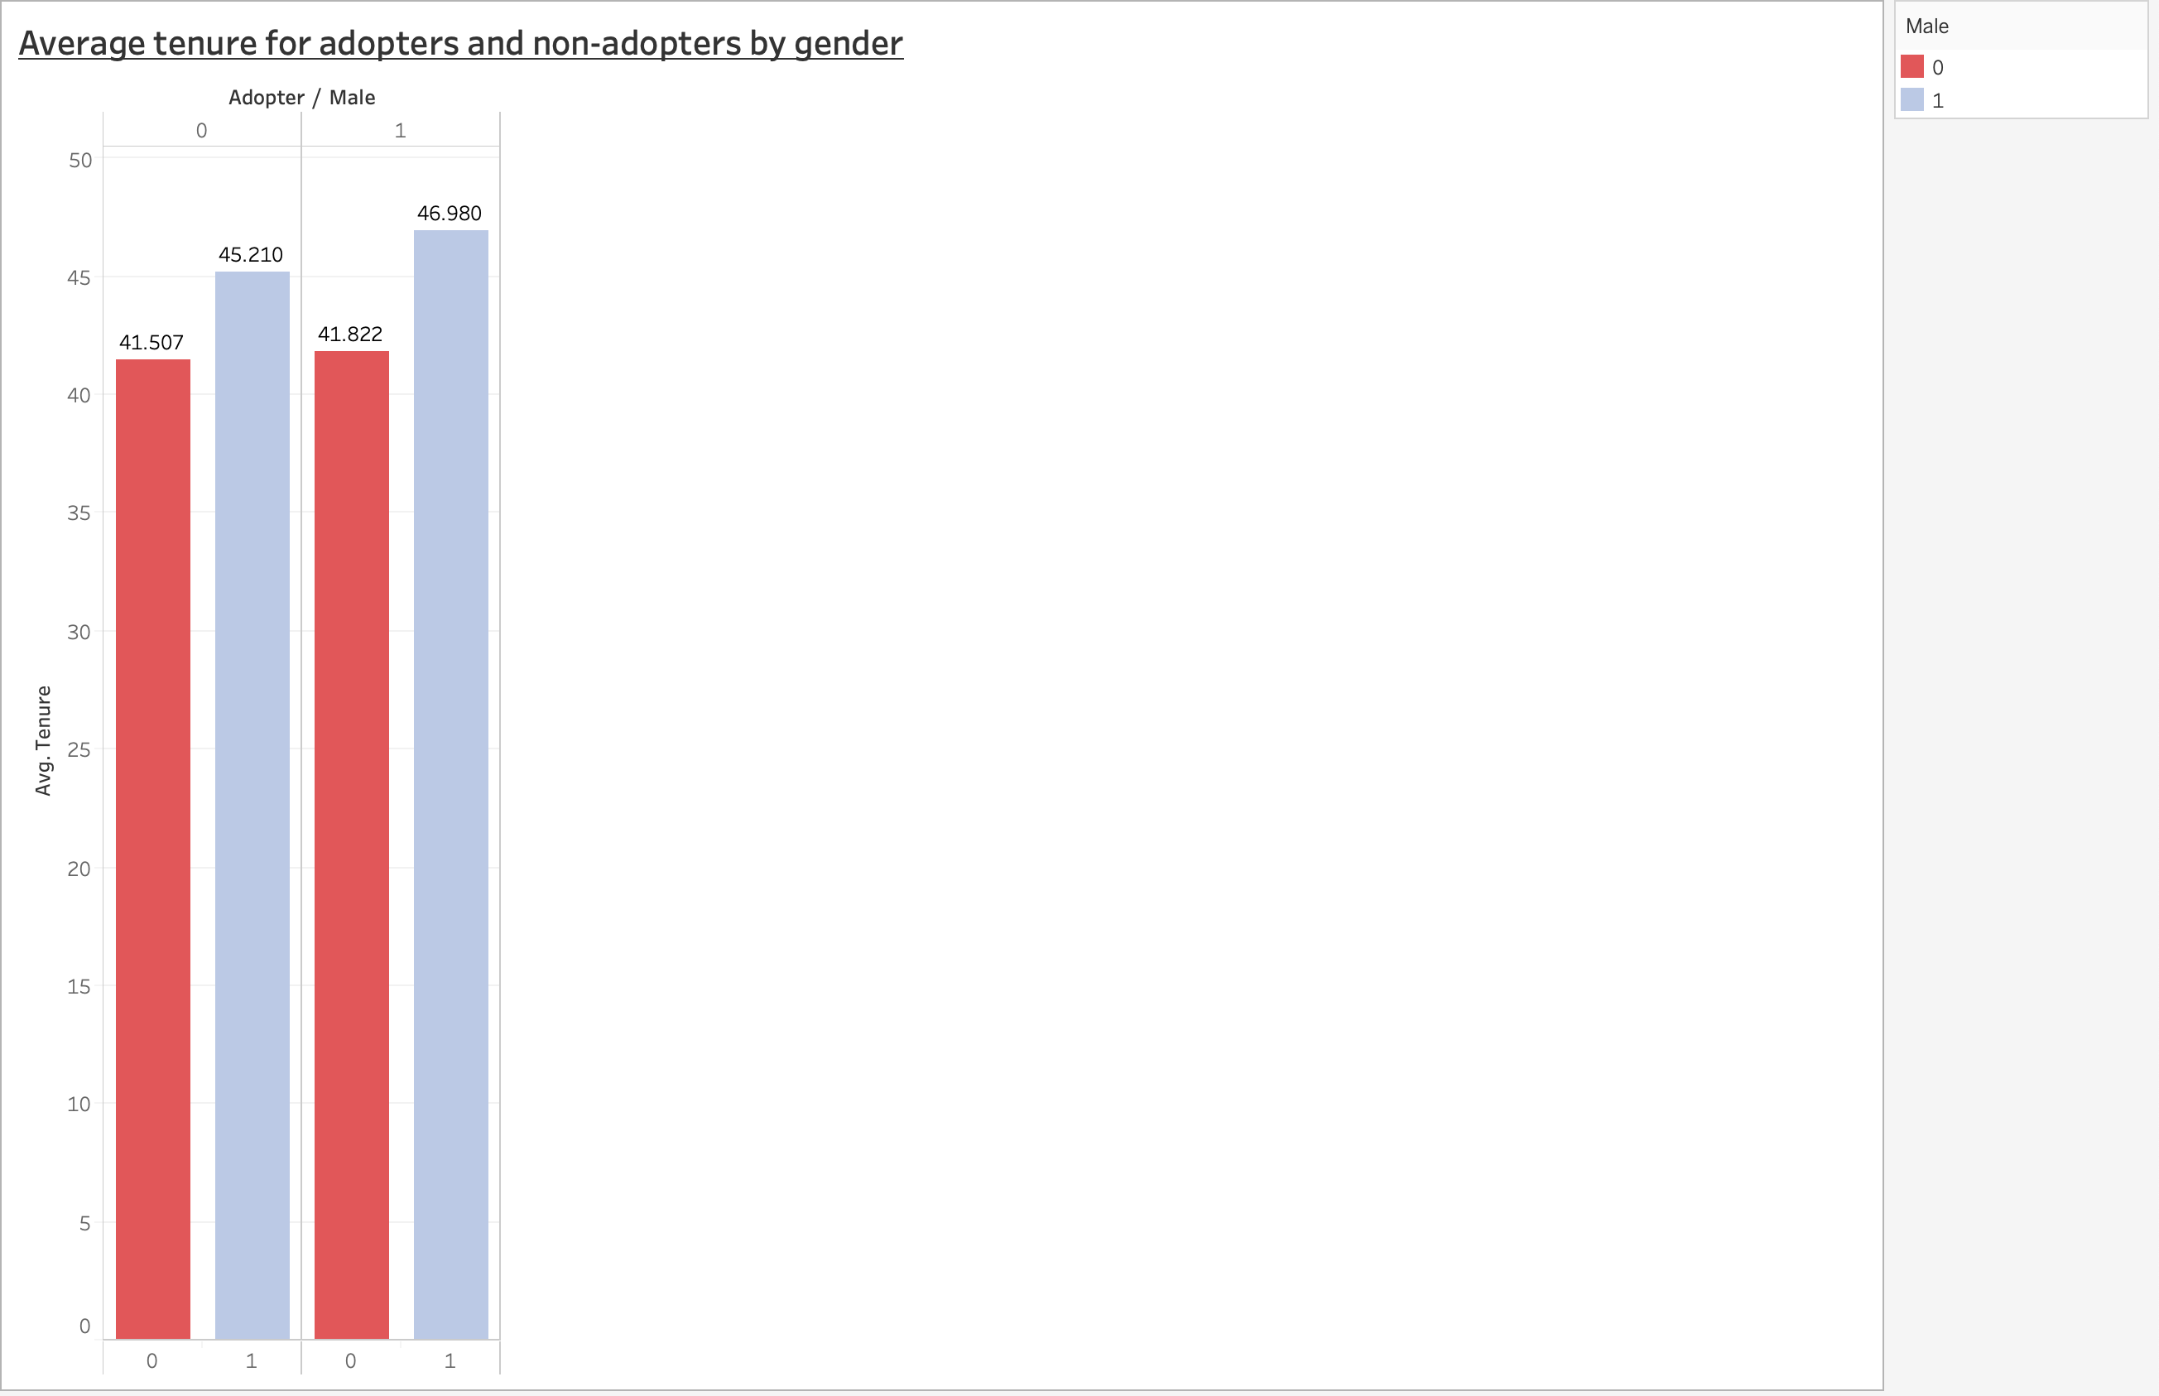

* After looking at the above plots –
  1. Talking about the most important factor for engaging the users on the platform, posts, shouts and loved tracks, I found that Average number of tracks liked by the female adopters was slightly greater than the male adopters though majority of the adopters are male. Thus, female adopters tend to like the songs in High-Note’s database and by marking certain tracks as loved, they even create another autogenerated playlist which increases their engagement with the platform.
  2. Looking at the average number of posts, here the male adopters dominated the female adopters and that average was almost twice that of female adopters. Thus, the male adopters are more active in terms of asking various queries to the music community than the female adopters.
  3. As far as shouts are concerned, the users on High-Note are biased towards appreciating female adopters as they have a higher number than male adopters in terms of average shouts.
  4. Moving on to the average number of songs listened by the users and total playlists created by the users, one thing is clear that male adopters listen to more songs on average than the female adopters. Thus, again the male engagement is more than the female adopters.
  5. As expected, going by the thumb of rule that, more the number of songs listened, more is the probability of creating a playlist, male adopters have almost 2.5 times total number of playlists than the female adopters.
  6. Lastly, male adopters on an average tend to stay longer with High-Note than female adopters and this shows that though female adopters love the songs posted by High-Note, it is the male adopter’s community that is more engaging and active than female adopters.

Q3 - Propensity Score Matching (PSM): You will use PSM to test whether having subscriber friends affects the likelihood of becoming an adopter (i.e., fee customer). For this purpose, the "treatment" group will be users that have one or more subscriber friends (subscriber_friend_cnt >= 1), while the "control" group will include users with zero subscriber friends. Use PSM to first create matched treatment and control samples, then test whether there is a significant average treatment effect. Provide an interpretation of your results.

* Creating a column ‘test’ where 1 indicates ‘treatment’ group and 0 indicates ‘control’ group.





* To check the number of observations for each treatment and control group.



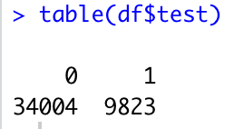

* To check the mean effect of treatment and control group across adopters.



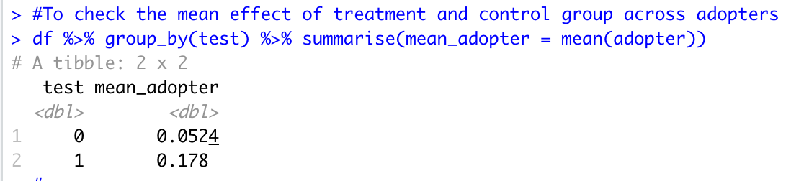

* This shows that the mean of treatment group is greater than that of control group.
* T-test to check statistical significance between the two groups.



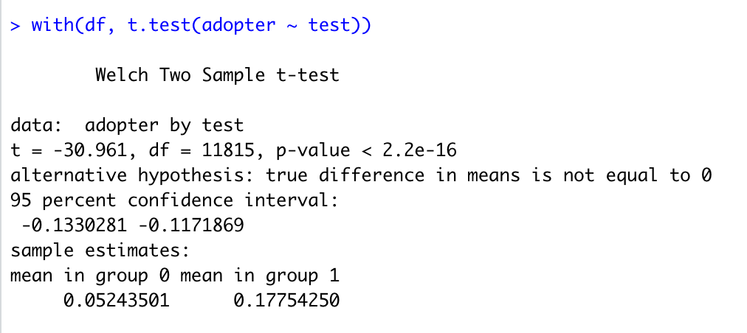

* The result of the T-test shows that difference in means of the two groups is statistically significant.

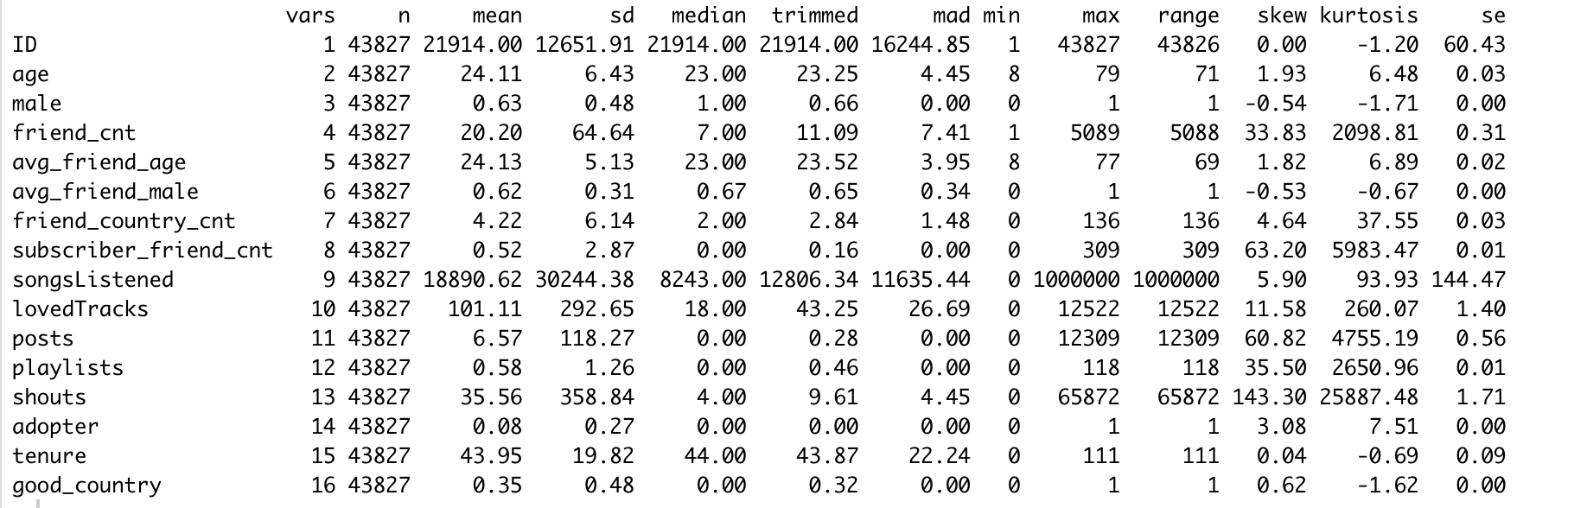

* After looking at the descriptive stats, we can see that some of the variables are highly skewed. Hence, we need to take the log of those variables such that all of those variables are on the same scale.
* Variables friend_cnt, friend_country_cnt, subscriber_friend_cnt, songsListened, lovedTracks, posts, playlists, shouts are highly skewed.

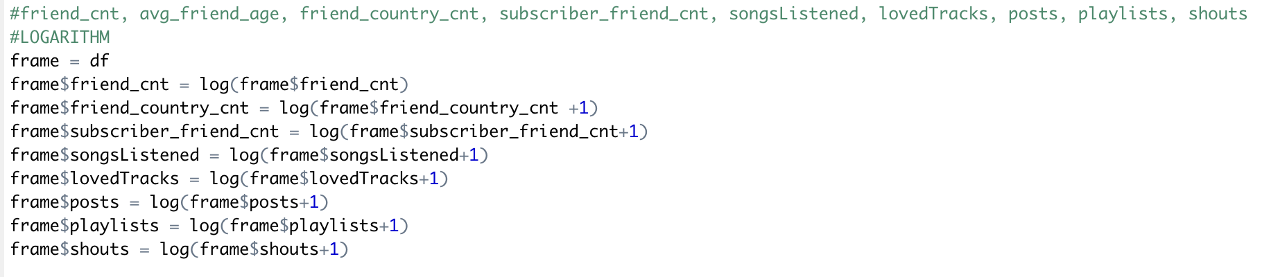

* Difference in means – pre-test covariates

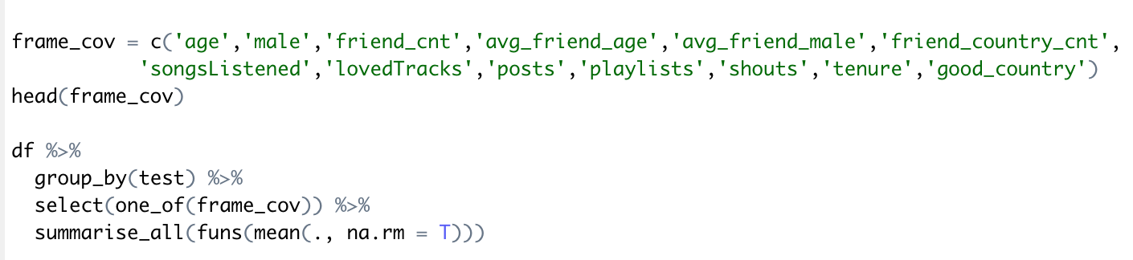

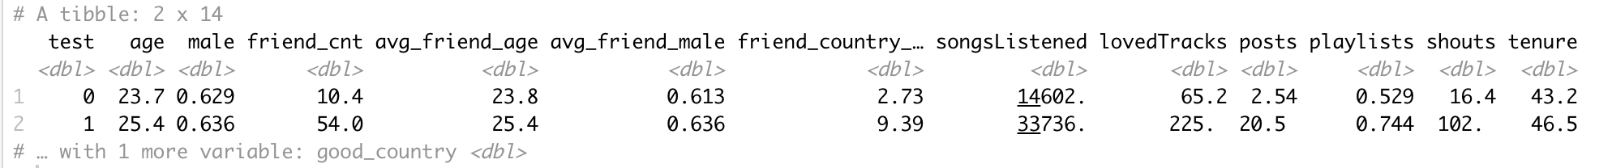

* After looking at the results, I found that the people in treatment group on an average have a greater number of friends as compared to control group. The treatment group has a diverse group of friends as compared to the control group. The treatment group members also listen to a huge number of songs as compared to the control group. The treatment group members are more active than the control group members which is indicated by the number of tracks loved by the ones in the treatment group. Lastly, on an average, the treatment group has a greater number of posts than the control group.
* Propensity Score matching –

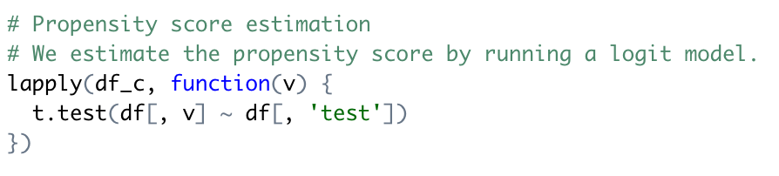

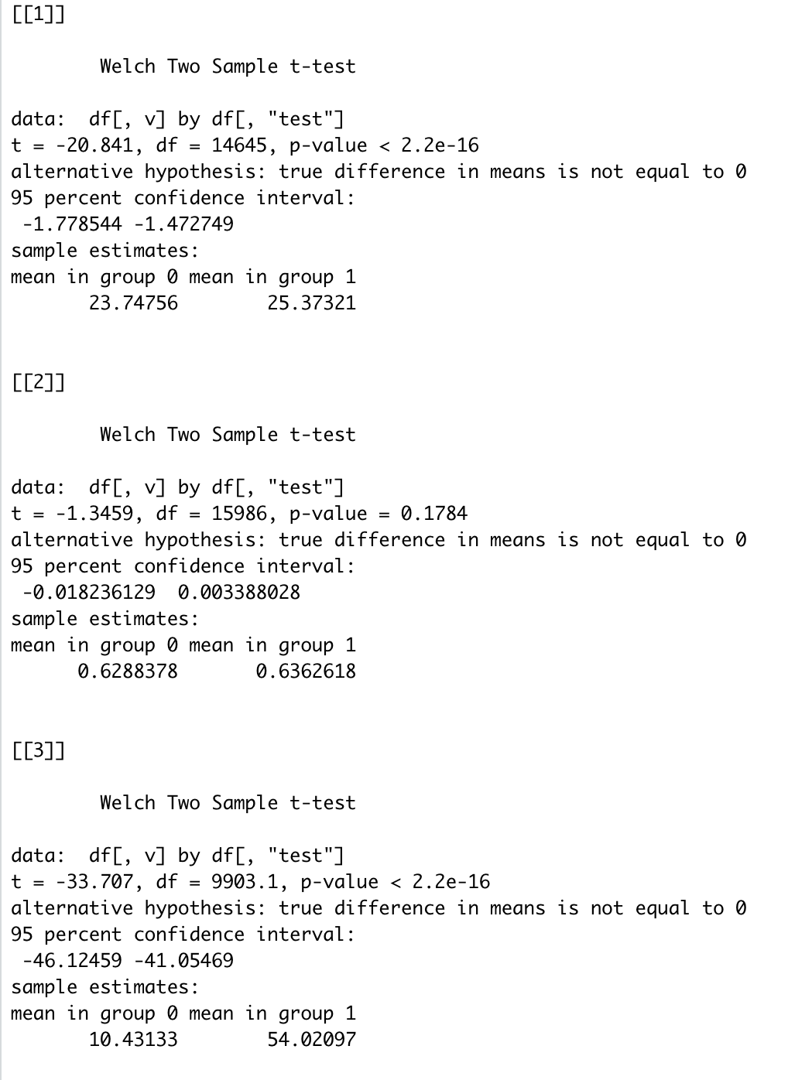

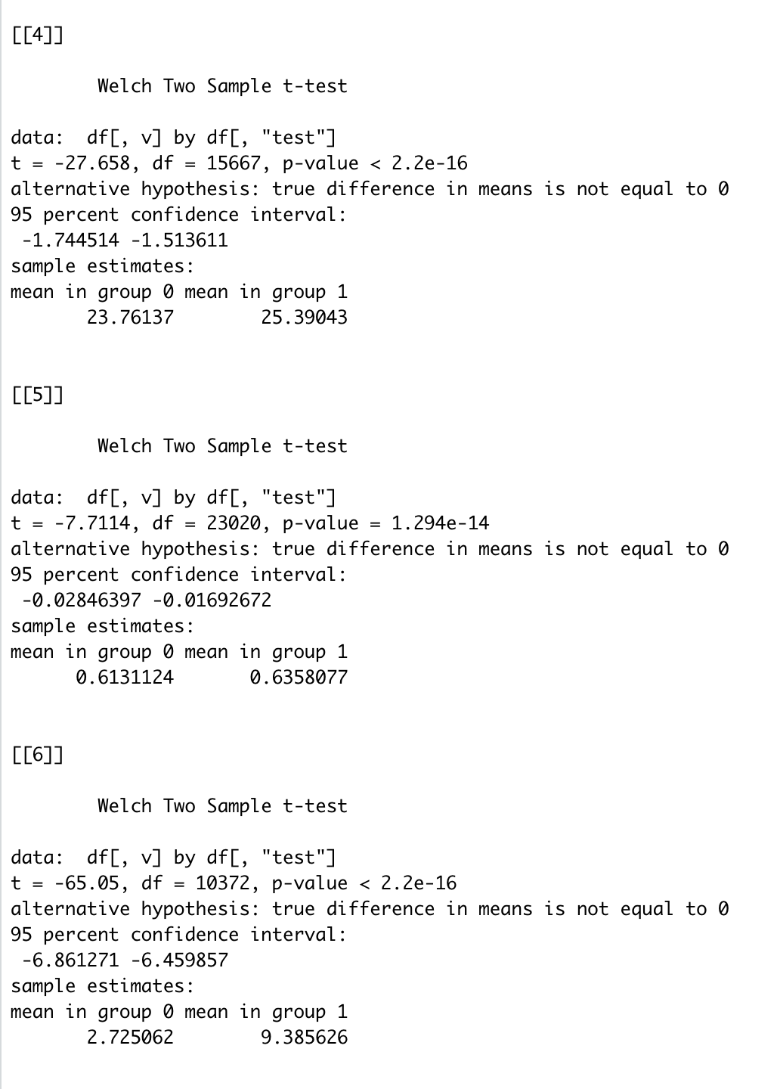

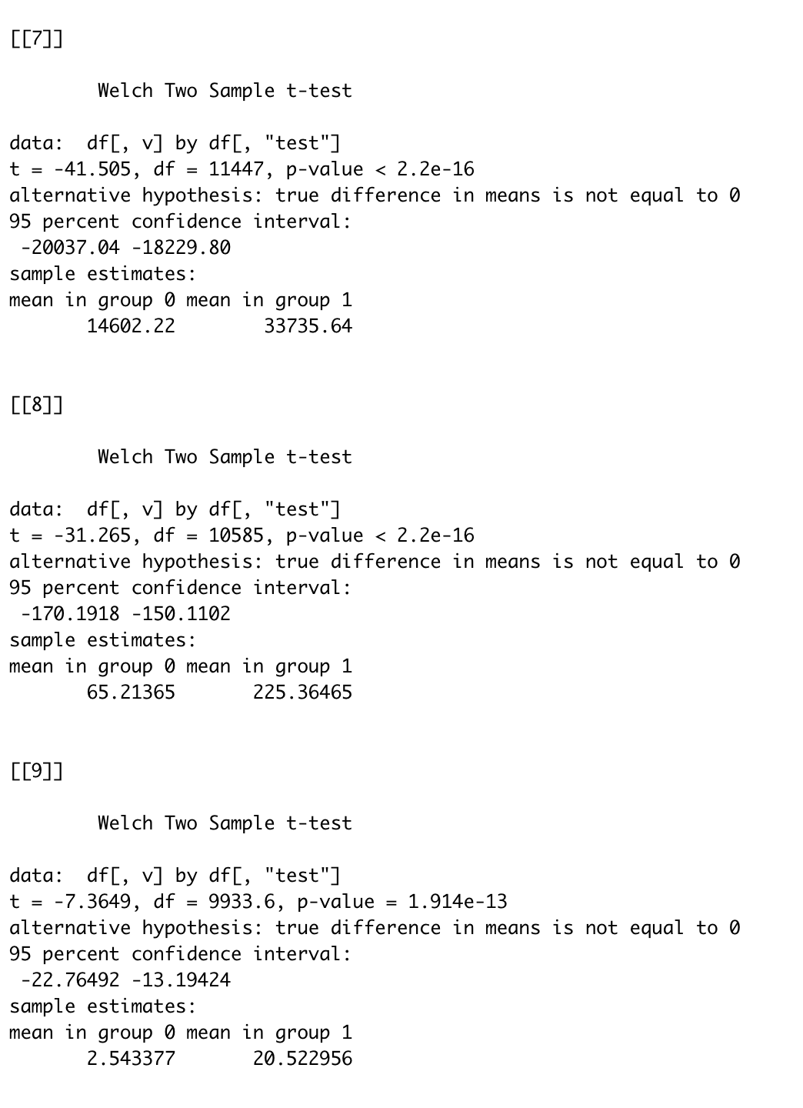

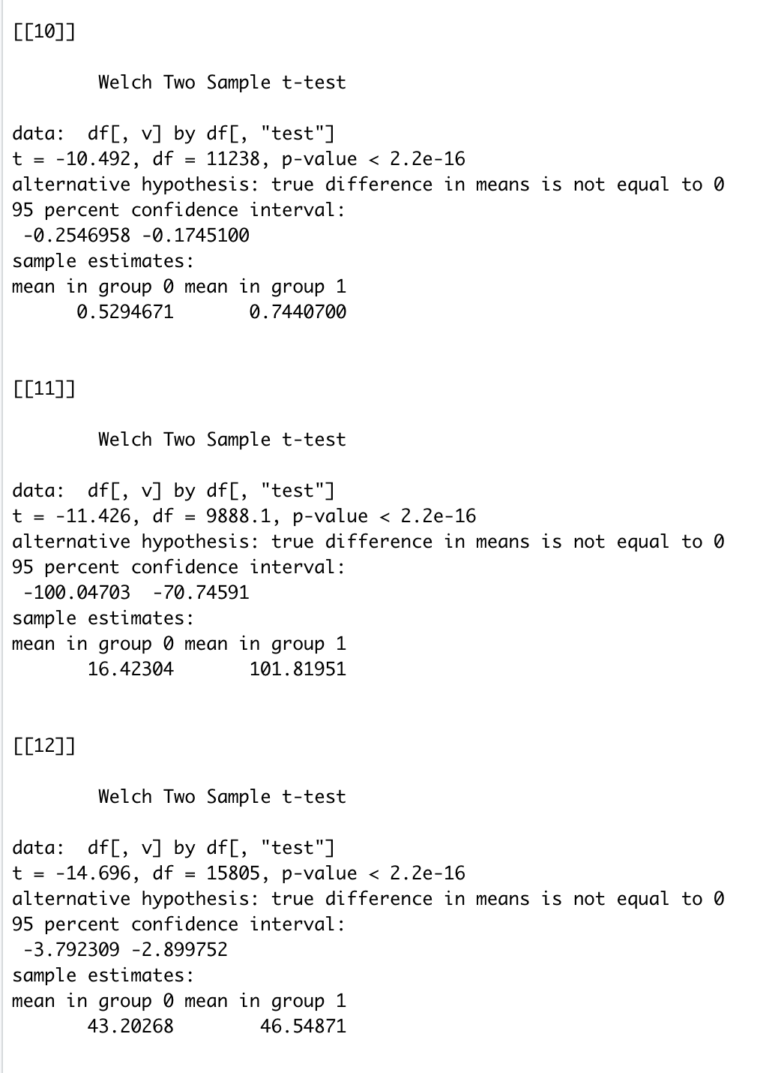

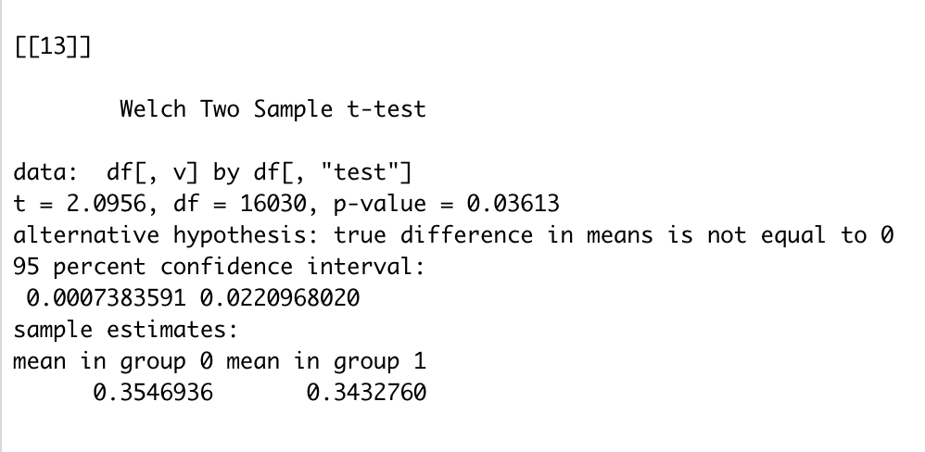

* After observing the results above, we can conclude that the treatment group and the control group are statistically distinguishable in all the factors except for the gender factor which is ‘male’ as the p-value for it is 0.17 which Is greater than 0.05.
* Logit model -

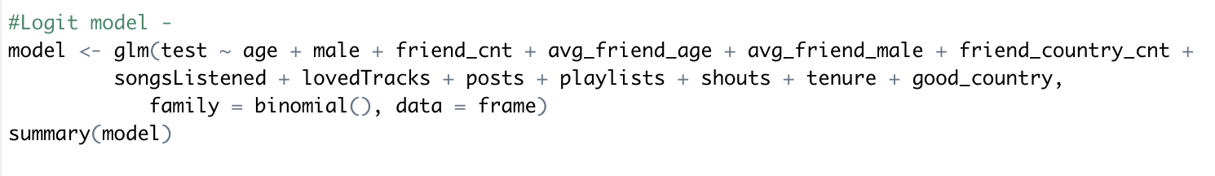

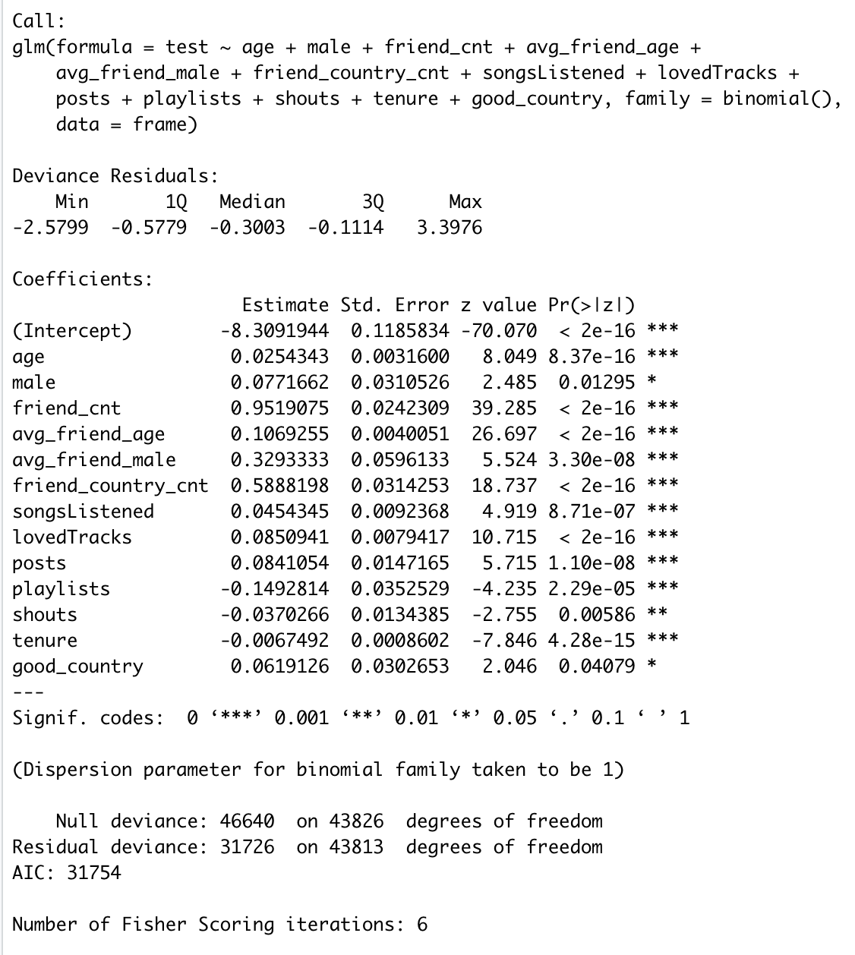

* Predicting the propensity scores -

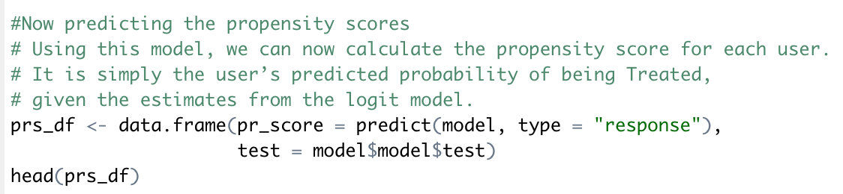

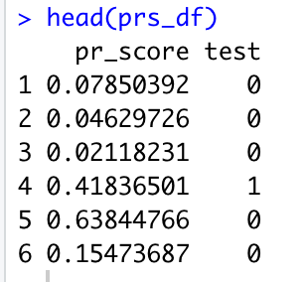

* Histogram for Control and Treatment group

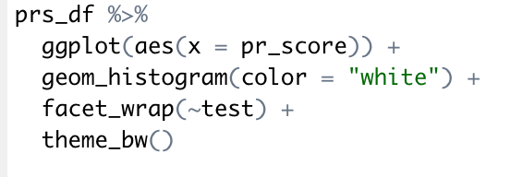

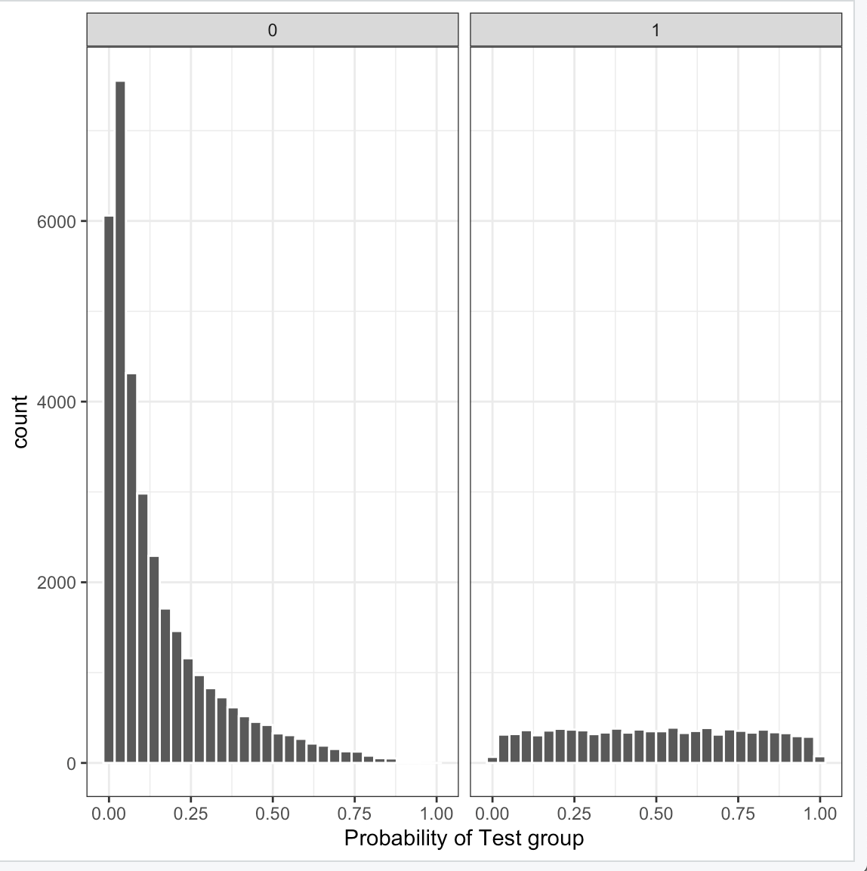

* From the above histogram, it is clear that the Control group histogram is rightly skewed whereas for treatment group, it is fairly constant.
* Using Matchit algorithm –

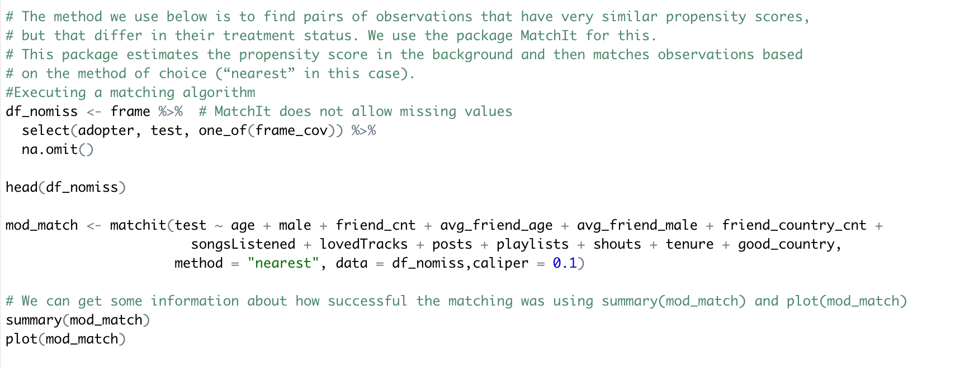

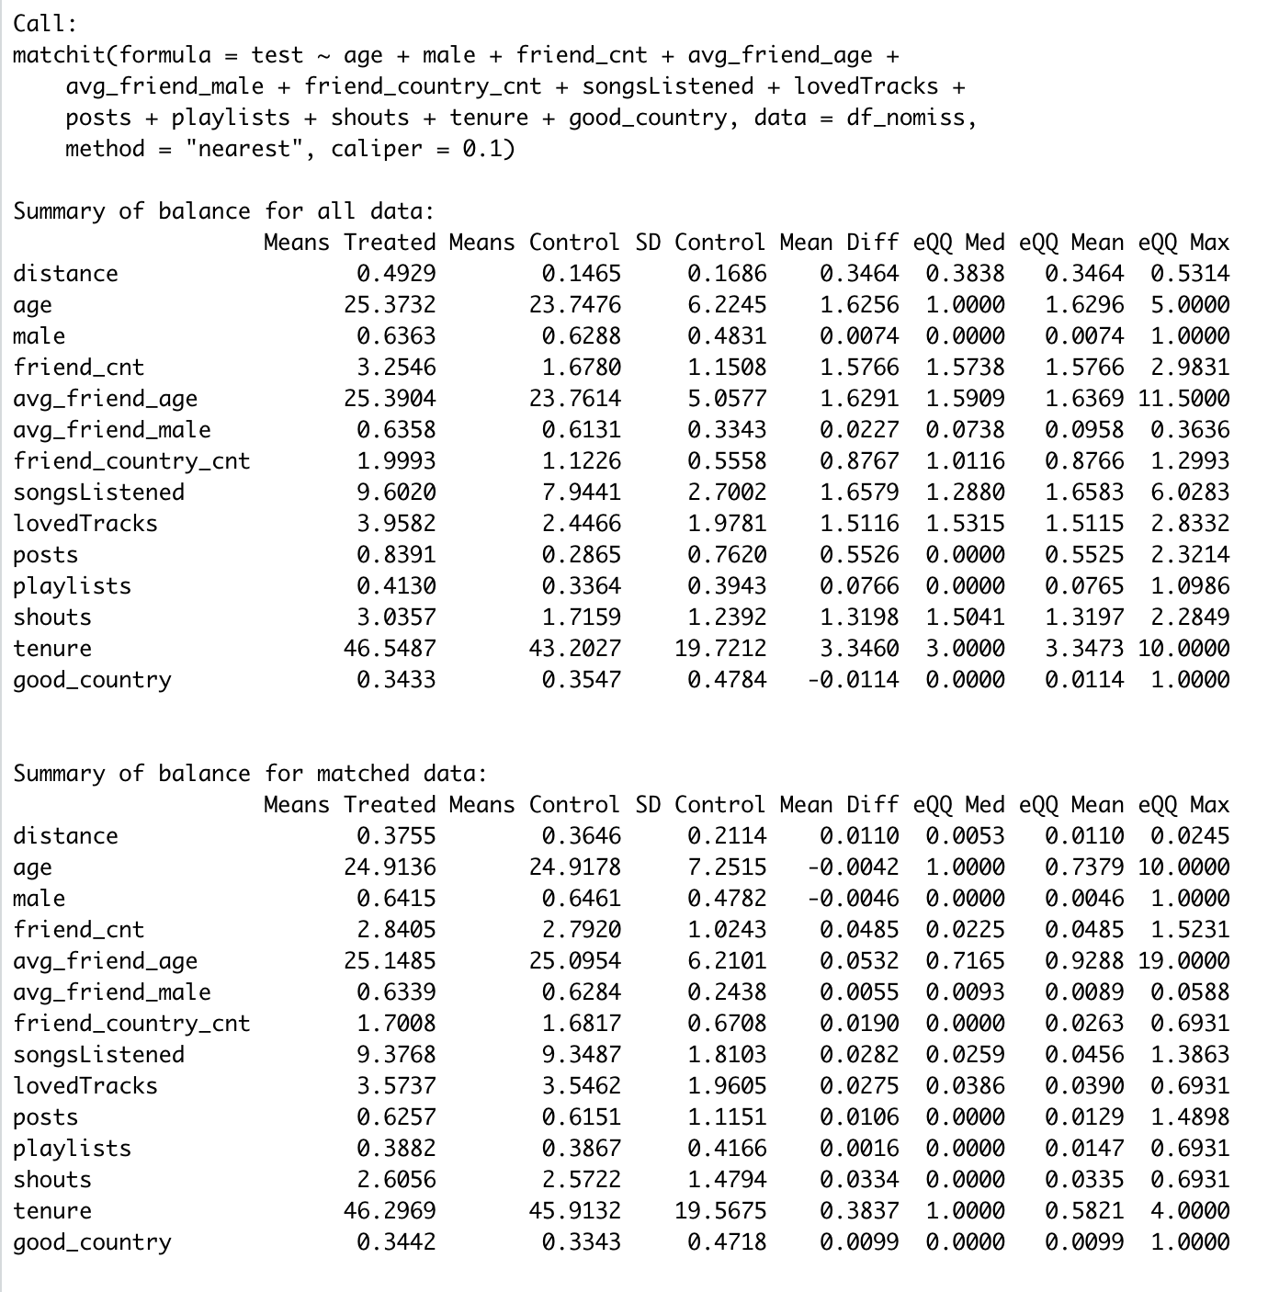

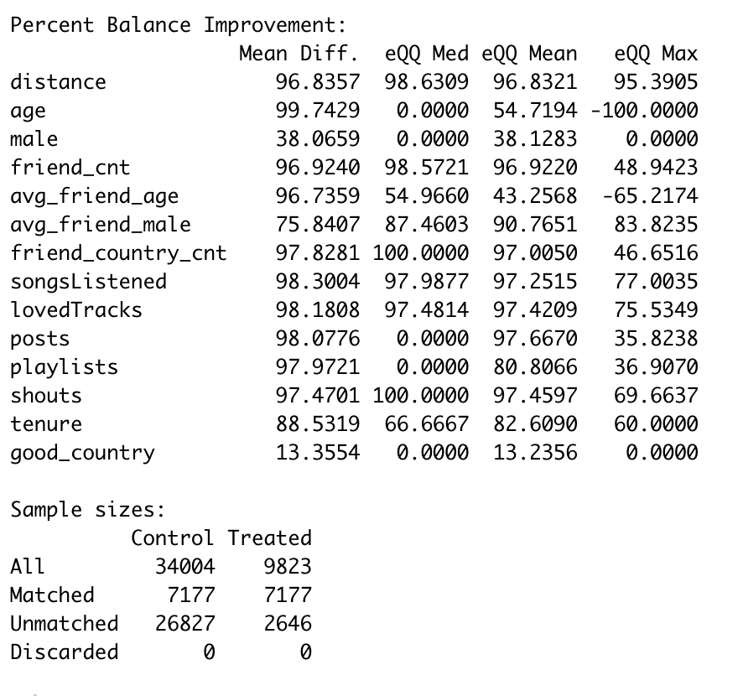

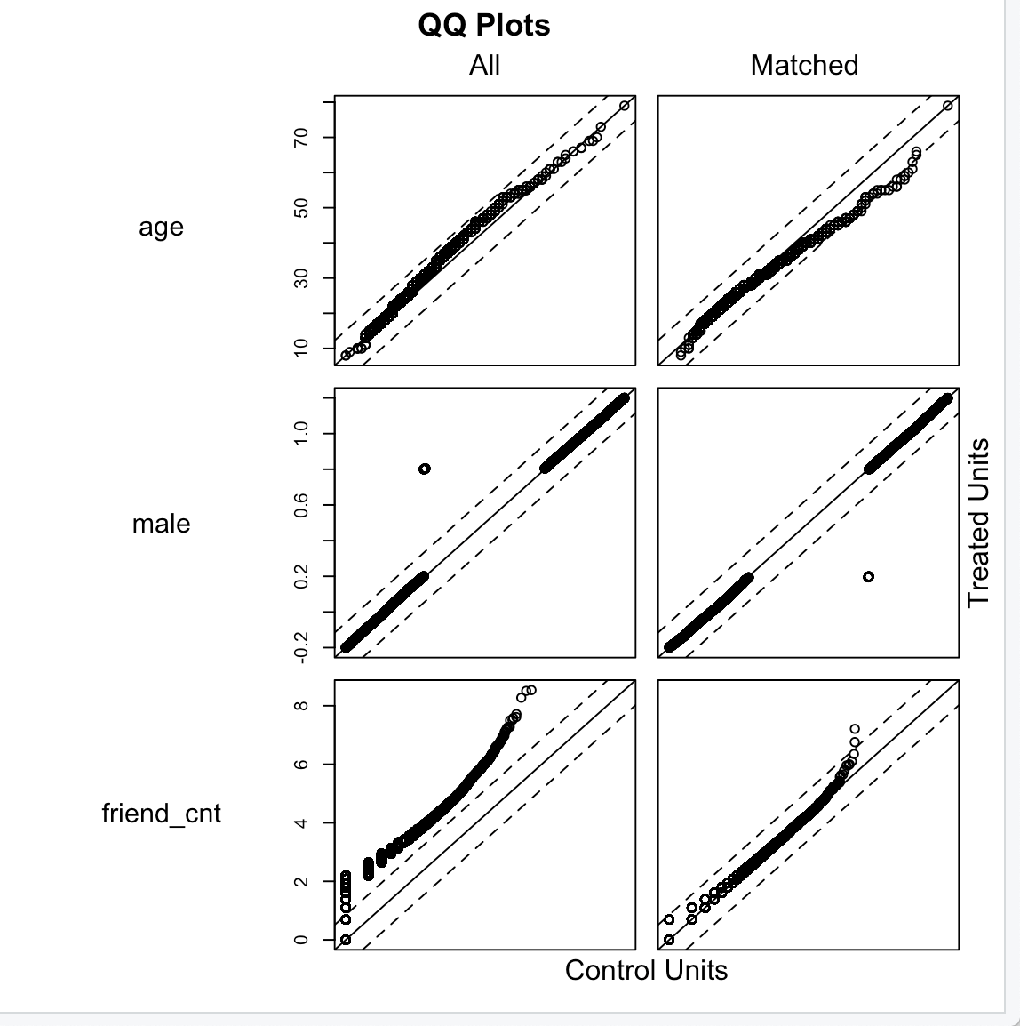

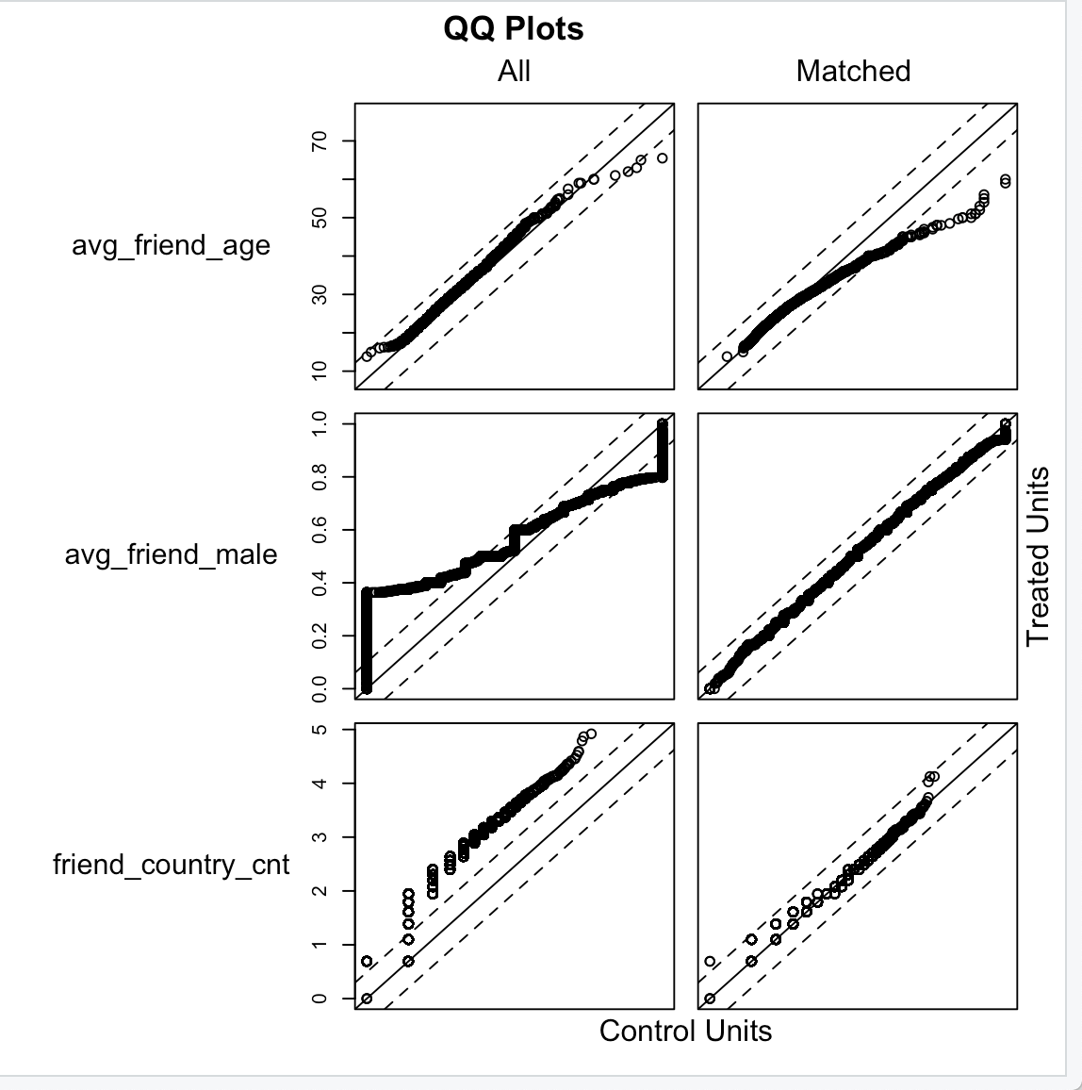

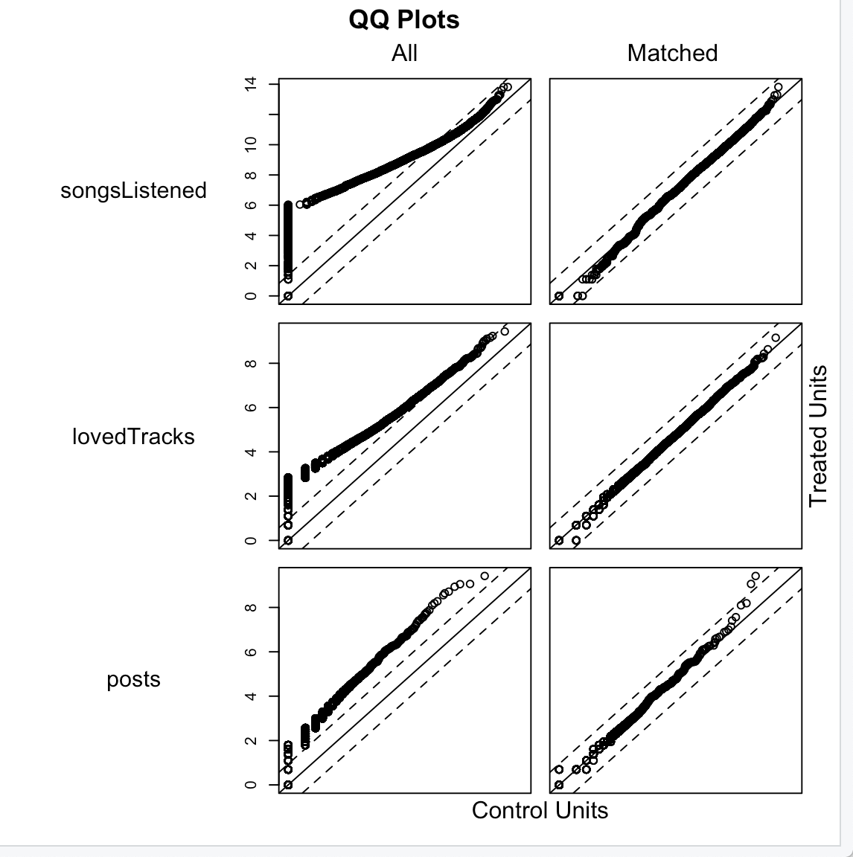

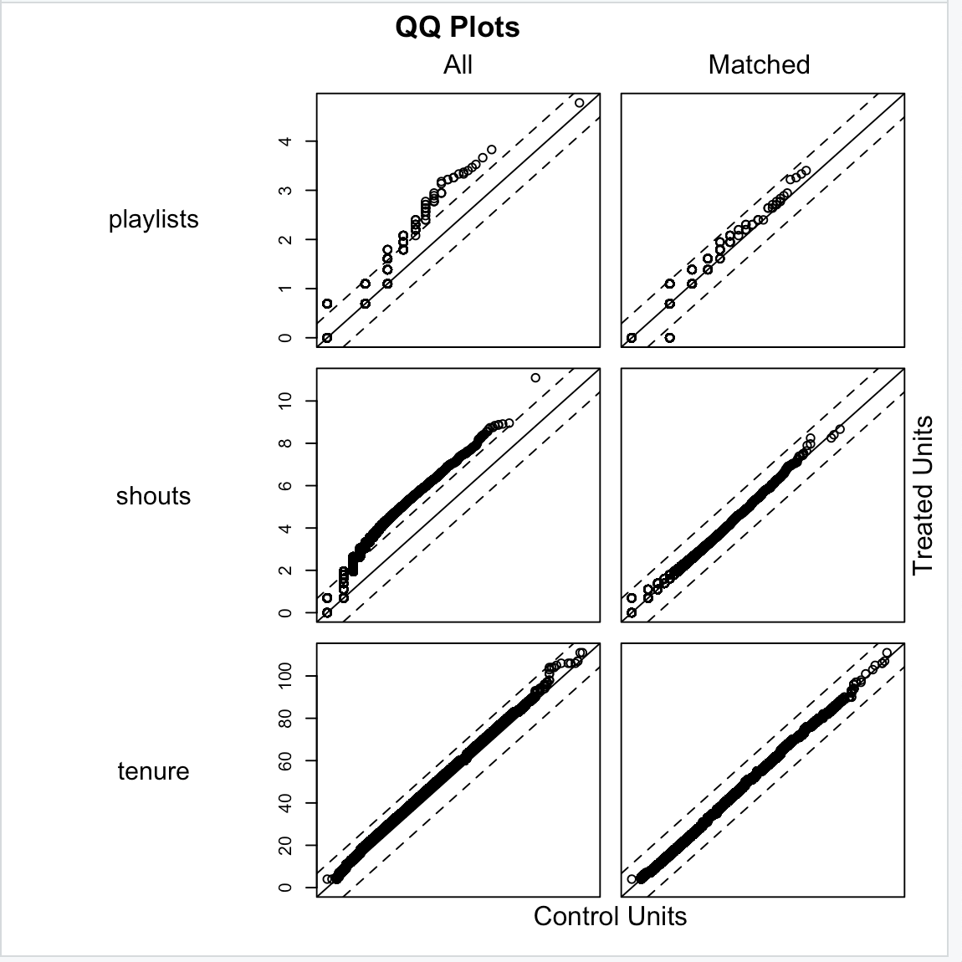

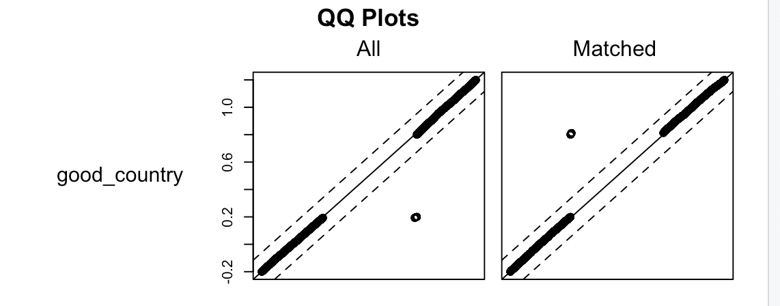

* The QQ plots show that the propensity algorithm used does well as most of the points lie on the diagonal line of the QQ plots. This shows that the data is better matched for control and treatment group.
* Visual Inspection –

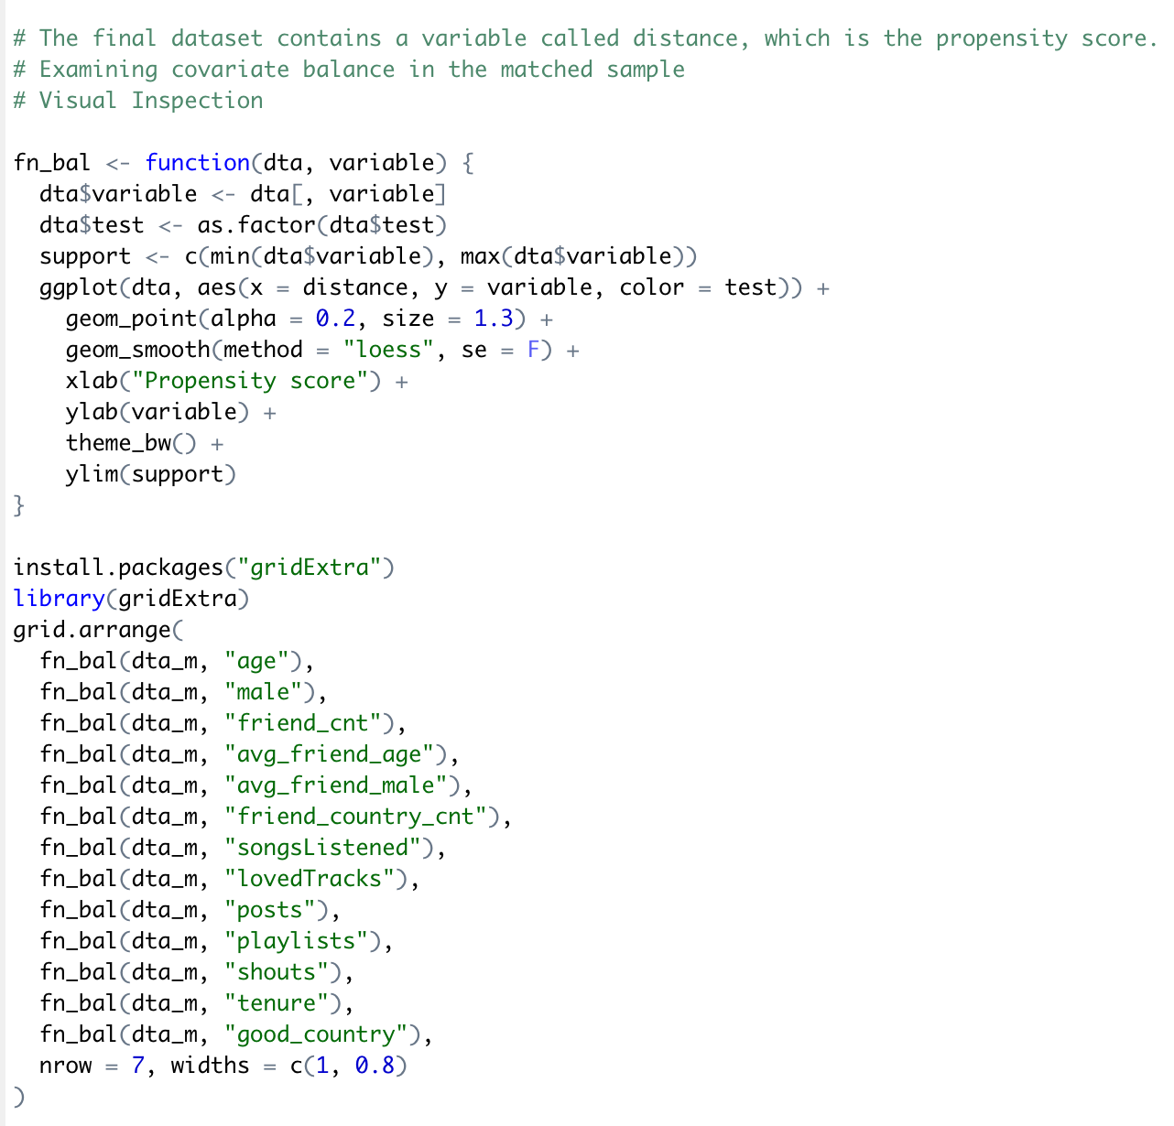

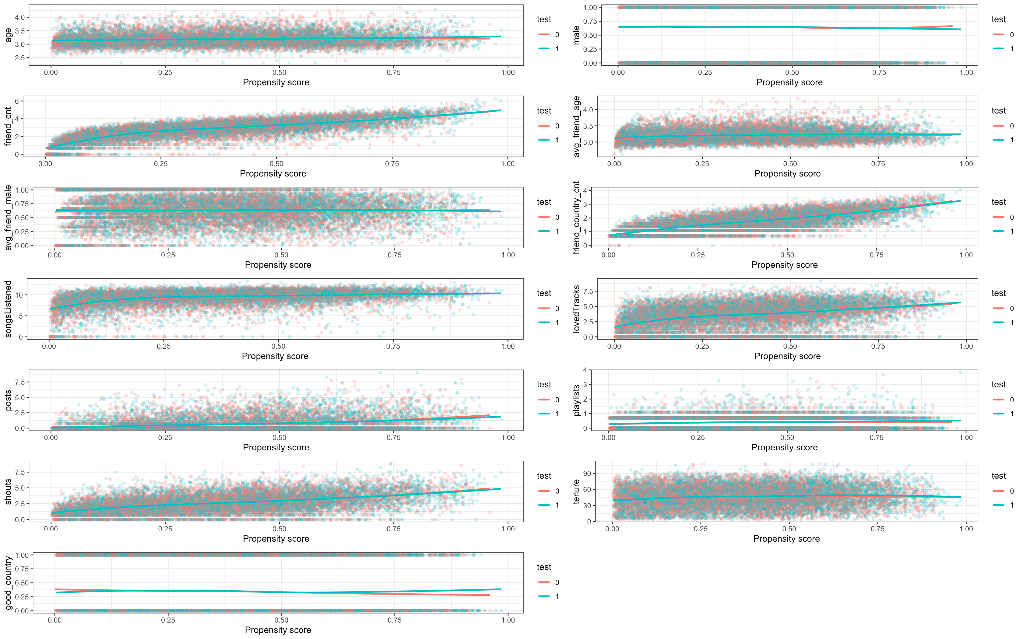

* Difference in means after matching algorithm (propensity score matching) –
* Performing the t-test to determine whether the new means are statistically different or not.

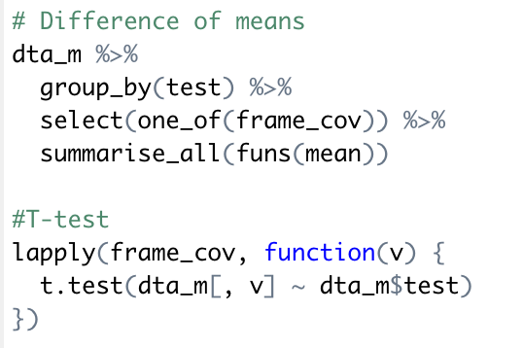



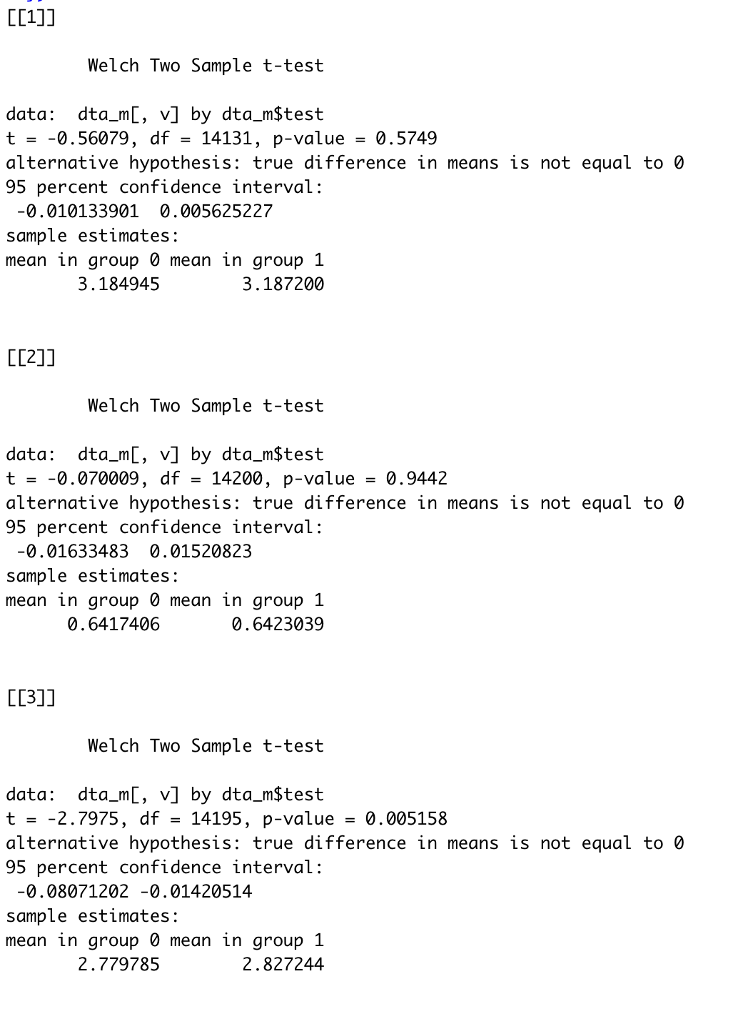

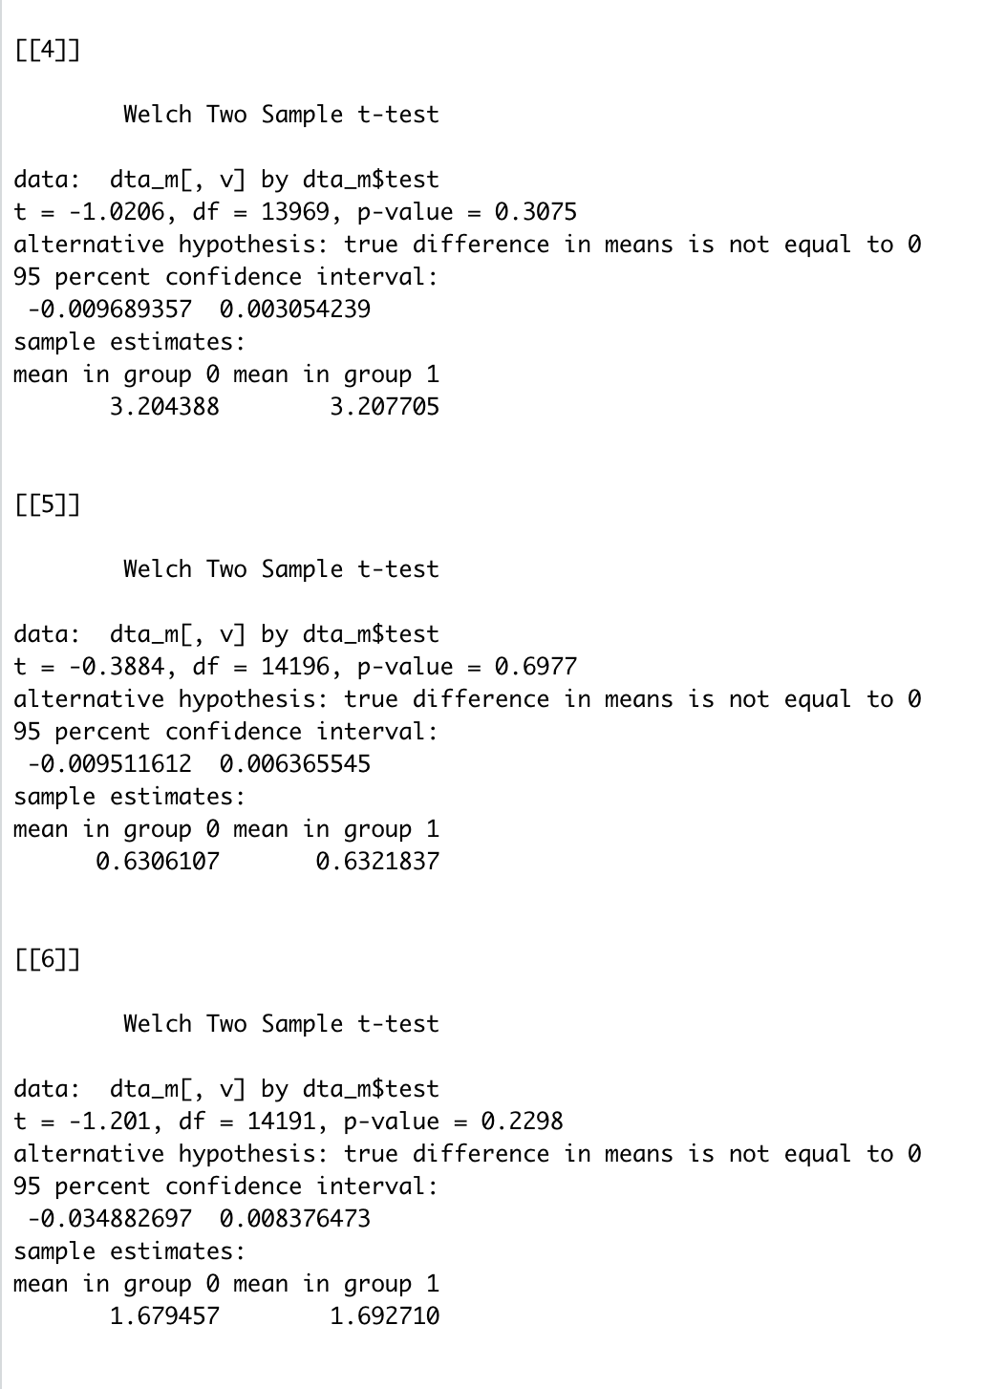

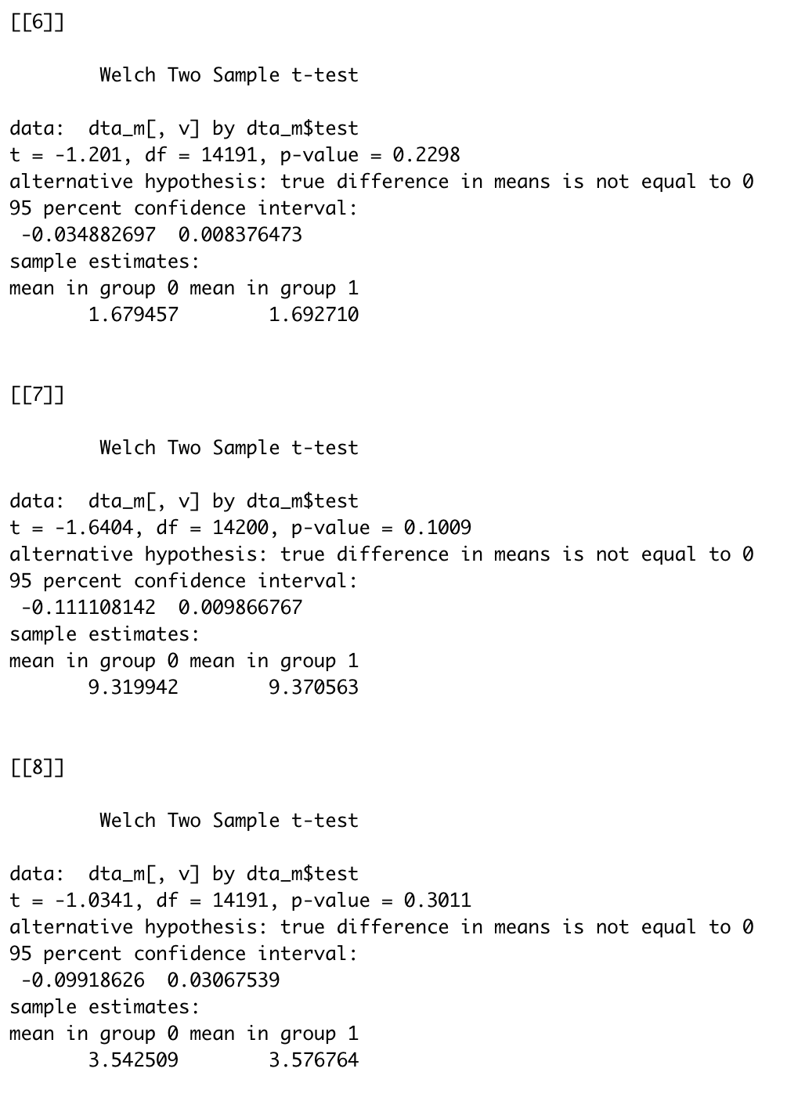

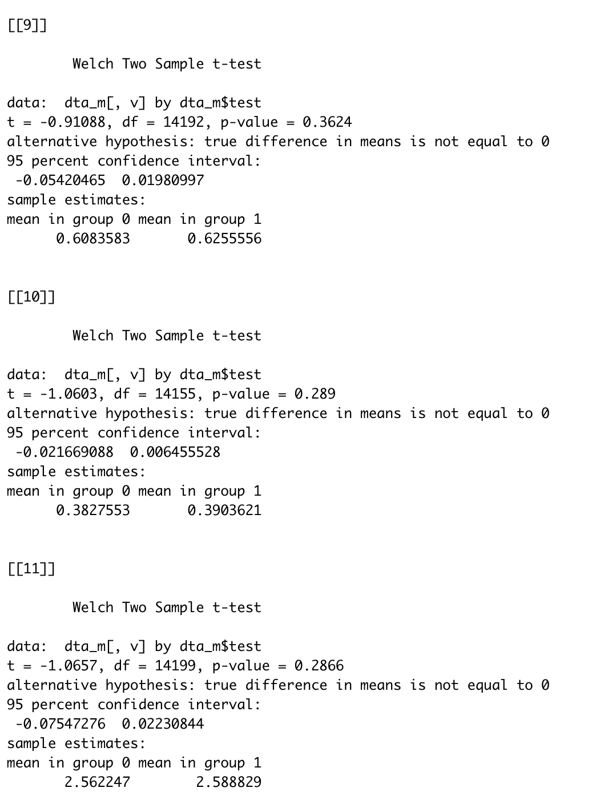

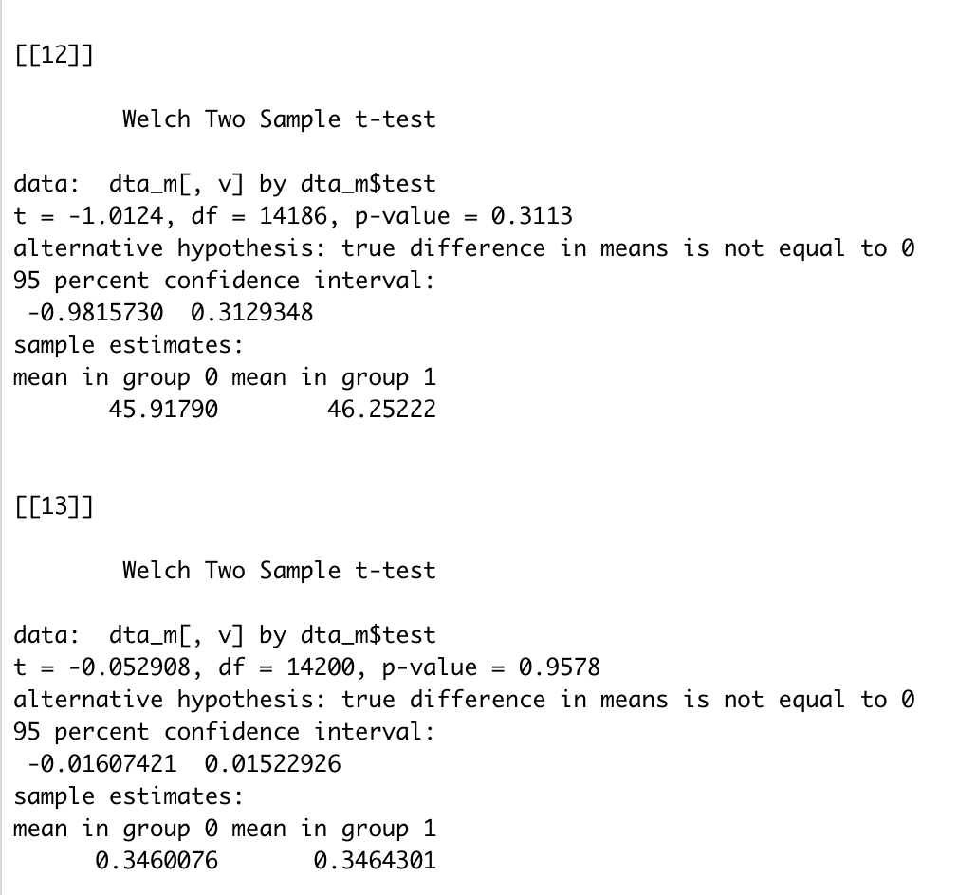

* Thus, from the above t-tests, we can see that almost all the variables are statistically insignificant with p-value > 0.05. Thus, it can be concluded the samples are well matched in the dataset.
* Checking whether there is statistical difference between treatment and control group after propensity matching.

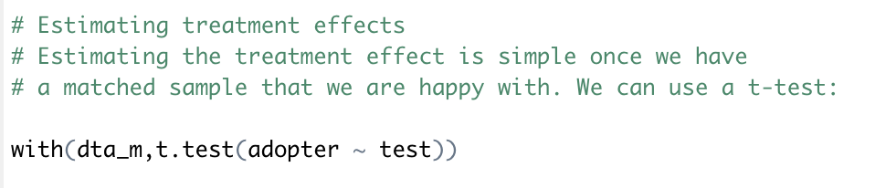

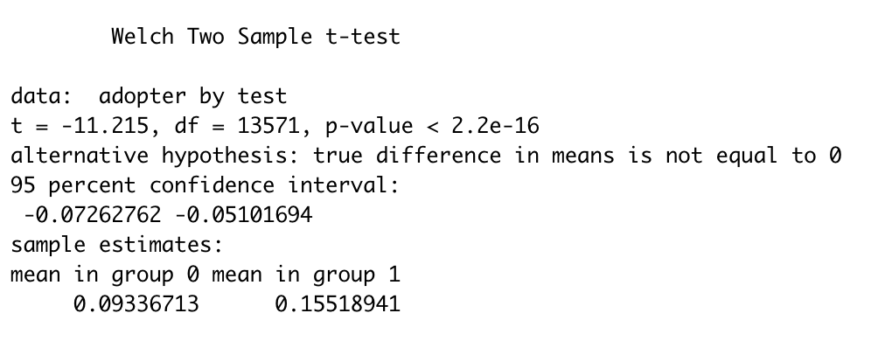

* As we can see from the result of t-test after propensity matching, there is statistical difference between the means of treatment and control group. This concludes that if a user has a set of subscriber friends, then there is a great chance of him being converted to a paid user or him being converted to an adopter.
* Using the OLS method to verify the statistical difference -

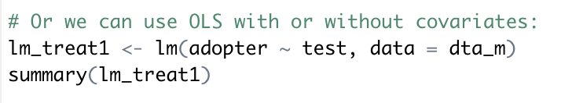

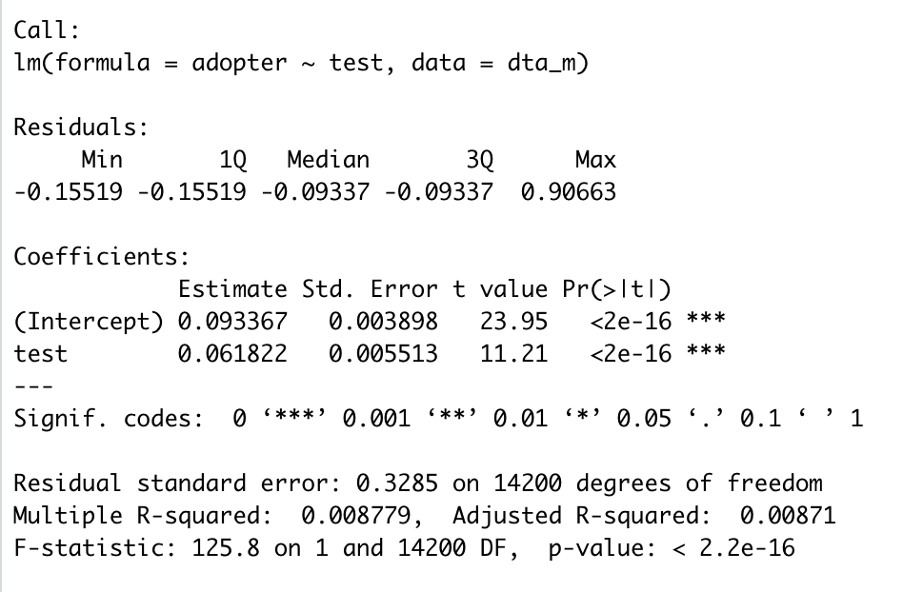

Q4 - Regression Analyses: Now, we will use a logistic regression approach to test which variables (including subscriber friends) are significant for explaining the likelihood of becoming an adopter. Use your judgment and visualization results to decide which variables to include in the regression. Estimate the odds ratios for the key variables. What can you conclude from your results?

* Logistic regression keeping all variables –

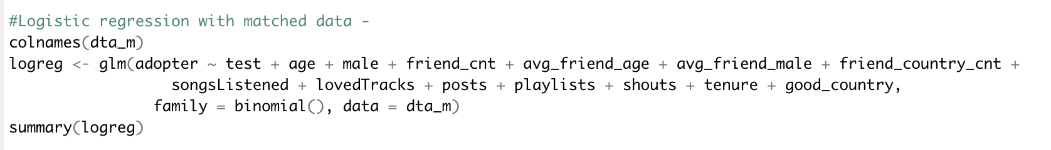

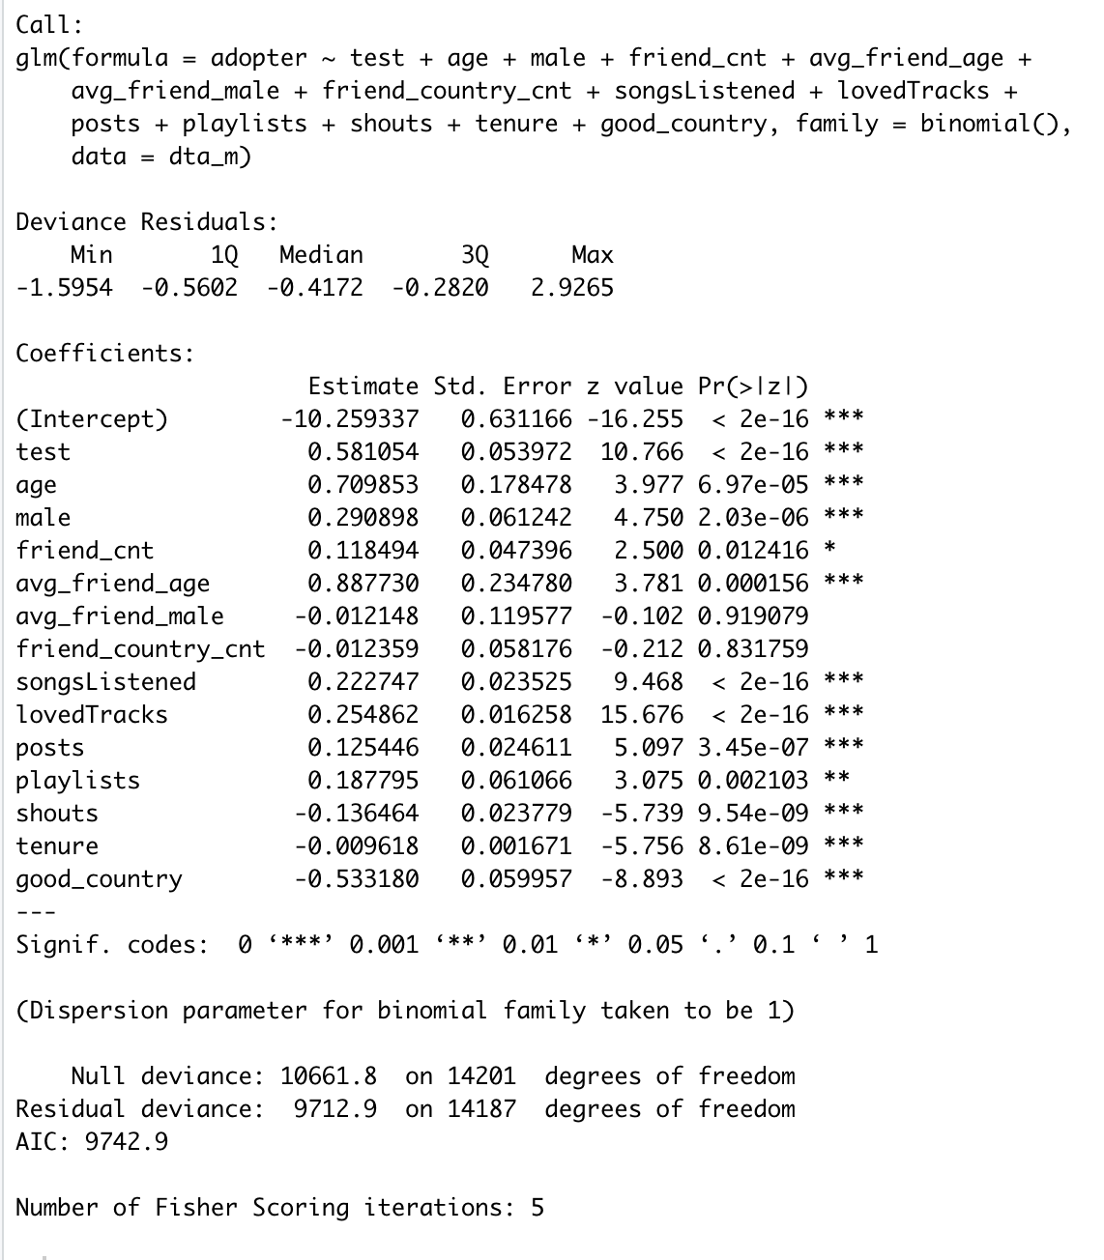

* From the above results, it is evident that the variables ‘avg_friend_male’, ‘friend_country_cnt’ are insignificant.
* Logistic Regression keeping only significant variables –

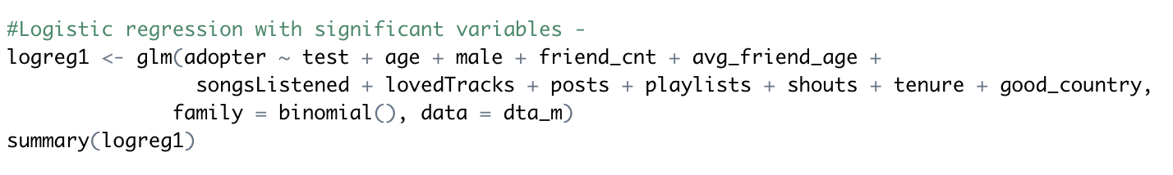

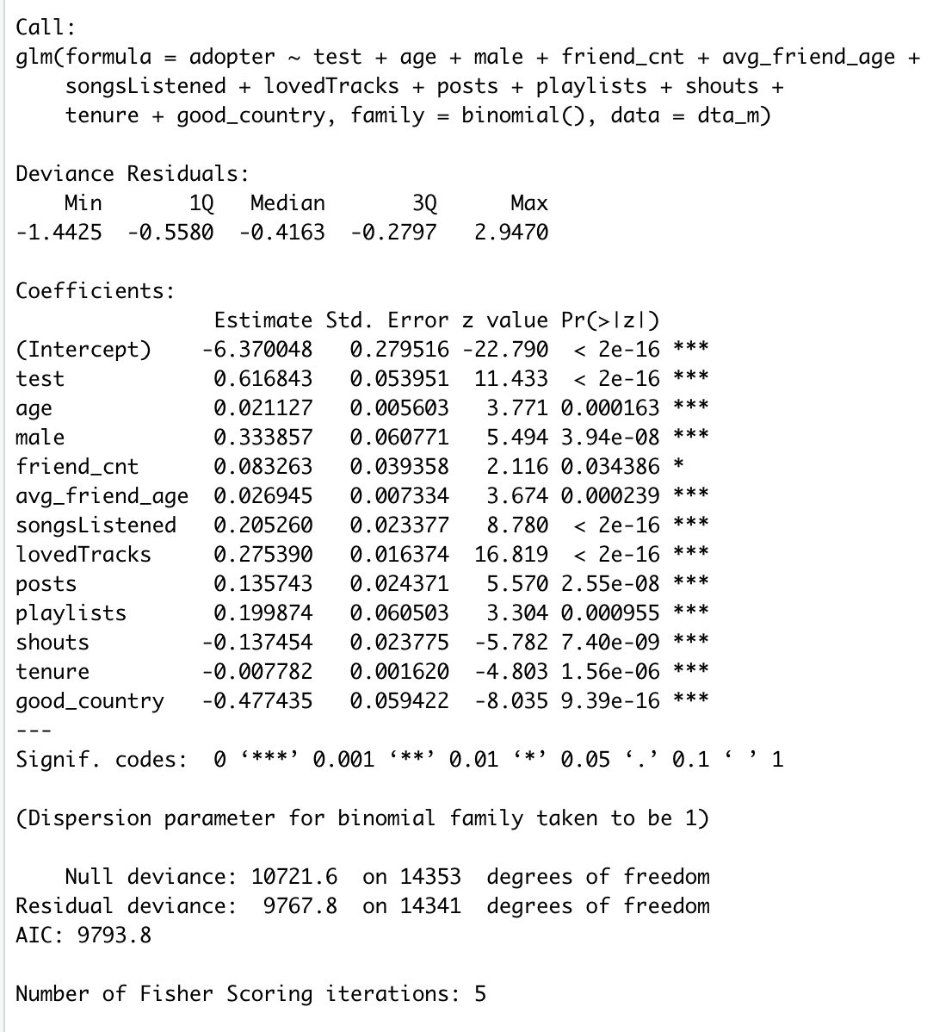

* Interpretation of the odds ratio –
* 𝑙𝑜𝑔(𝑝/(1−𝑝))=𝛽0+𝛽𝑙𝑜𝑔(𝑋)log(p/(1−p))=β0+βlog(X)
* **Then, each**𝑘k**-fold increase in**𝑋X**is associated with a change in the odds by a multiplicative factor of**𝑘𝛽kβ**.**
* Taking exponent of the coefficients which are log(odds) to get the actual odds ratio

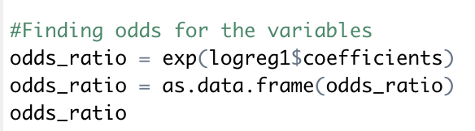

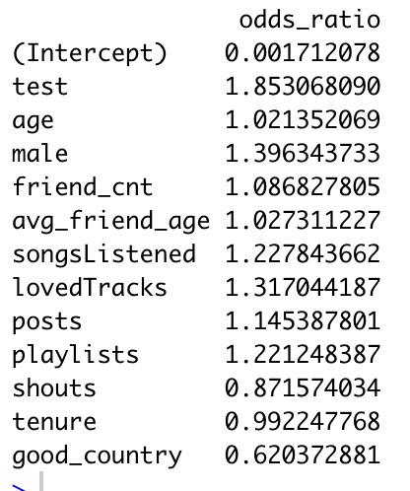

* After looking at the odds ratio, we can conclude that: -
  1. If a person has made a new friend which is already a subscriber for high note (**test variable**), then the chances of that person being an adopter increase by 85% keeping all other variables constant.
  2. A 1 unit increase in the **age** of the user will increase his/her chances of him/her being an adopter by 2 % keeping all other variables constant.
  3. In case of **gender**, if a person is male, then there are high chances of him being an adopter as the odds of being an adopter for male is 1.396 times that of female.
  4. For **log(friend_cnt)**,each 2.71828-fold increase in friend_cnt is associated with a change in the odds of being an adopter by a multiplicative factor of1.086 keeping all the other variables constant.
  5. A 1 unit increase in **the average age** of the user’s friends will increase his chances of being an adopter by 2.735% keeping all other variables constant.
  6. For **log(songsListened)**,each 2.71828-fold increase in songsListened is associated with a change in the odds of being an adopter by a multiplicative factor of1.2278 keeping all the other variables constant.
  7. For **log(lovedTracks)**, each 2.71828-fold increase in lovedTrack is associated with a change in the odds of being an adopter by a multiplicative factor of 1.317 keeping all the other variables constant.
  8. For **log(posts)**, each 2.71828-fold increase in number of posts is associated with a change in the odds of being an adopter by a multiplicative factor of 1.1453 keeping all the other variables constant.
  9. For **log(playlists)**, each 2.71828-fold increase in number of playlists is associated with a change in the odds of being an adopter by a multiplicative factor of 1.2212 keeping all the other variables constant.
  10. For **log(shouts)**, each 2.71828-fold increase in number of shouts is associated with a change in the odds of being an adopter by a multiplicative factor of 0.8715 keeping all the other variables constant.
  11. For **tenure**, for every additional month spend by the user on the platform, his chances of being an adopter decrease by 0.77% keeping all other variables constant.
  12. In case of **good_country**, if a person is from US, UK or Germany, then there are less chances of him being an adopter as the odds of being an adopter for a person from US, UK or Germany is 0.664 times that of a person who is not from these 3 countries.

Q5 - Takeaways: Discuss some key takeaways from your analysis. Specifically, how do your results inform a “free-to-fee” strategy for High Note?

* After a analyzing the high-note case, following are the takeaways –
  1. Logistic Regression results show that gender has a significant effect on a person being an adopter for High-Note. Male users tend to be the majority adopters as compared to the female population. Thus, to increase the female adopter count even more, high note can focus on adding tracks or genres such as rock, jazz, etc. which are mostly preferred by the male population.
  2. As observed from the regression, having subscriber friends for a user increases his chances of being an adopter by 85%, thus if high-note can offer some group discounts such as say group of 5 will get some sort of family plan subscription like mobile service providers, then there is a great chance of free users getting converted to paid ones or fee users.
  3. Also, High note can introduce a referral program wherein adopters will get say a month extra or some perks on the platform so that number of adopters can go up.
  4. Also, we observed that for every playlist created, the odds of user being an adopter increase by a factor of 1.2212. Thus, high note can bring an innovative marketing strategy to the market by saying that if a user creates a playlist, he/she can get a coupon for any local restaurant or say discounts for the first month of premium subscription.
  5. As we can see, high note is performing pretty good in countries except for US, UK, Germany as these countries have a negative effect on a person being an adopter. Thus, a large share of the marketing campaigns should be focused on these developed countries as there is a lot of potential to target customers in these developed economical markets.
  6. From data visualization, it was clear that there were a smaller number of female adopters as compared to male adopters. Thus, High-Note should probably think of strategies to drive an increase in their feminine users such as special discounts on women’s day, special offers or coupons exclusively for girls, or maybe couple discounts which may enable High-Note to use its dominant male users.
  7. Also, from the EDA, we saw that the most dominant age group for High-Note was one between 20-25. Thus, High-Note can introduce special student programs such as 3 or 6 months of free trial like Amazon does with its 6 months student trial program. This way, High-Note can increase its customer base as students are the ones who are more active on their mobile phones using new and innovative applications.